We thank the Editor and the Reviewers for their helpful comments. We reply in detail to each comment raised. We have made the necessary changes in the manuscript as suggested and feel that we have significantly improved the manuscript.

REVIEWER C:
- The article is well writen and the topic very relevant, specially because it identifies specific needs in training and gives simple suggestions on how to improve diagnosis, treatment and orientation of patients with anaphylaxis.
Minor suggestions/corrections were made within the document.
Reply: Thank you, all the suggestions were accepted, and changes were made throughout the document.
- A suggestion for an additional reference is given (in the document) for a paper and poster to be used in this setting, since this can help to disseminate already available content on anaphylaxis.
Reply: Thank you for your suggestion. We added in Discussion: “This is an ongoing concern of the Sociedade Portuguesa de Alergologia e Imunologia Clínica (SPAIC), that prompt the release, in 2018, of a clinical poster on the diagnosis and treatment of anaphylaxis, to be disseminated throughout the acute clinical setting²⁷.”; and in Conclusion: “The authors also recommend the use of the SPAIC poster.”
- I encourage the authors to contact the Interest group on Anaphylaxis of SPAIC (Sociedade Portuguesa de Alergologia e Imunologia Clínica) if they wish to collaborate with further projects in this field.
Reply: Thank you. We will do that.

REVIEWER D:
The manuscript is well written and presents interesting data about anaphylaxis. It may contribute for a better anaphylaxis diagnosis and treatment, particularly in terms of adrenaline use. Some methodological clarifications and corrections should be implemented. Please check the English language.
A) Introduction
1. A more comprehensive review about the frequency / prevalence of anaphylaxis in Portugal should be included.
Reply: Thank you, unfortunately there are not many Portuguese data on anaphylaxis epidemiology. Nevertheless, we add in Introduction: “Data regarding the incidence and prevalence of anaphylaxis in Portugal are scarce and dubious, since there is a high level of underdiagnosis and under notification. The Health General Directorate, through the Clinical Standard no. 002/2012 of 04/07/2012 updated in 11/08/2015, required the registry of all allergy and adverse reaction cases, including anaphylaxis, in the Portuguese Catalogue of Allergies and Other Adverse Reactions (CPARA). Data registered between 2012 and 2013 demonstrates an incidence of anaphylaxis of 11,2 per 100.000. However, even though this value can serve as guidance, it probably underestimates the real incidence of the problem.”
B) Methods
1. This is a retrospective study and not a retrospective cohort study (correction should be extended to the abstract).
Reply: Acknowledged and corrected as follows:
In Abstract:
“Methods: Retrospective study of adult patients attending the Emergency Department of a tertiary care Portuguese hospital, over a year, with anaphylaxis.”
“Métodos: Estudo retrospetivo da população adulta que recorreu ao Serviço de Urgência de um hospital terciário português durante um ano, com anafilaxia.”
In Methods:
“This work constitutes a retrospective study, based on a consecutive series of adult patients (≥ 18 years of age at the date of admission) diagnosed with anaphylaxis, admitted in the ED of HSA-CHP, between November 1st, 2015, and October 31st, 2016.”
2. Who collected the data and assessed the ICD cases in order to decide the presence or absence of anaphylaxis?
Reply: Thank you for your question. ICD-9 codes were requested from and given by this hospital statistical department. All cases were reviewed by the authors, both the medical student and the thesis advisor (Intensive Care consultant).
We add in the text: “The sample included all cases registered with discharge ICD-9 codes 995.0, 995.1, 995.2, 995.3, 995.6, 995.60, 995.61, 995.62, 995.63, 995.64, 995.65, 995.66, 995.67, 995.68, 995.69 and 995.7, who, after careful analysis of the clinical registers by the authors, were found to meet the currently accepted clinical criteria for the diagnosis of anaphylaxis (Table 5).”
3. When was the questionnaire distributed to the physicians? Which questions were included?
Reply: The questionnaires were distributed and collected within a period of a week (between 9 and 15 April 2018) to all ED physicians that attend patients triaged to Medicine or General Practice. This included: all HSA-CHP physicians from the Internal Medicine Department, who have weekly shifts in the ED; General Practice physicians hired by HSA-CHP to work exclusively in the ED; physicians hired from an external company who work shifts in Medicine or General Practice in the ED; and physicians that work in the Emergency Room (receives patients who are given red Manchester triage colour at admission).
We added in Methods: “Questionnaires were distributed and collected within a period of a week (between 9 and 15 April 2018) to all above mentioned HSA-CHP ED physicians.”
The questionnaire used is attached here. If the editor/reviewer finds it useful, we can add it as supplementary material.
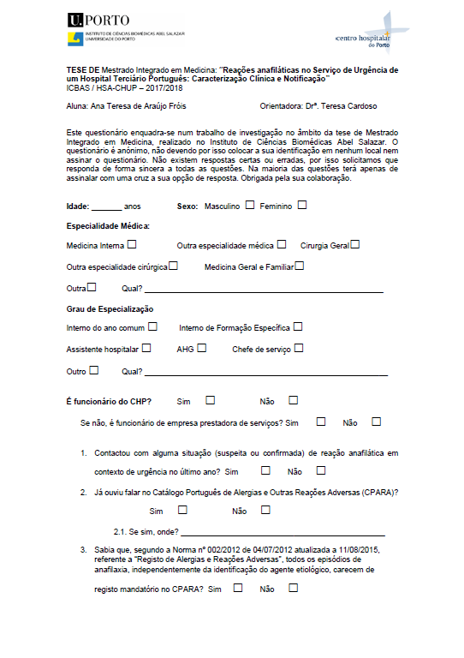
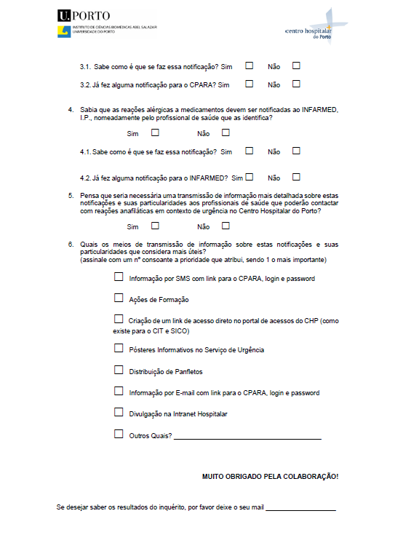

C) Results
1) Only 7% of the ICD cases related to anaphylaxis were classified as “real anaphylaxis”. How could the authors explain this low rate?
Reply: Thank you for your question. From the initial sample of 972 cases fulfilling the ICD-9 codes selected, only 69 (7%) of patients met the clinical criteria for anaphylaxis. This is mainly due to the fact that a specific code for anaphylaxis is missing in the ICD-9. ICD-9 codes either consider “allergy” or “anaphylactic shock”, which leaves out the rest of the spectre of anaphylactic reactions. For this reason, physicians have difficulty in attributing a specific ICD-9 code for an anaphylaxis event, and reactions such as mild allergic reaction are attributed the same code as an anaphylactic reaction. Patients with only: mucocutaneous symptoms, respiratory symptoms or gastrointestinal symptoms, those with history of exposure to a known allergen without clinical symptoms, the intra-hospital allergic reactions, or other diseases mistakenly codified as allergic reactions were excluded from our study.
We add to the text:
In Results: “Reasons for exclusion included the presence of only mucocutaneous symptoms, respiratory symptoms, or gastrointestinal symptoms, exposure to a known allergen without clinical symptoms, intra-hospital anaphylactic reactions, or other pathologies mistakenly codified as allergic reactions.”
In Discussion: “From the initial sample of 972 cases fulfilling the ICD-9 codes selected, only 69 (7%) of patients met the clinical criteria for anaphylaxis. This is mainly due to the fact that a specific code for anaphylaxis is missing in the ICD-9 classification. ICD-9 codes either consider “allergy” or “anaphylactic shock”, which leaves out the rest of the spectre of anaphylactic reactions. For this reason, physicians have difficulty in attributing a specific ICD-9 code for an anaphylaxis event, and reactions such as mild allergic reaction are attributed the same code as an anaphylactic reaction.”
2) The total number of cases seen in the studied period (independently of the presence of the ICD) could be mentioned in order to estimate the incidence or frequency of “real” anaphylaxis.
Reply: Thank you. This is mentioned in the first line of the results: “Medical records of 972 patients satisfying the admissible discharge ICD-9 codes were analysed; 69 patients met the criteria for anaphylaxis.”.
3) Concerning the sentence “None of the evaluated variables demonstrated a significative relation with the severity of the anaphylactic reaction”, please specify the variables and p value. Additionally, the statistical test used should be included in methods. Do the authors mean statistically significant association? If so, please correct.
Reply: Thank you very much for this very important point raised. We have added in Methods the following: “Comparisons between categorical variables were made using Chi-Square and Fisher exact test. For continuous variables with normal and non-normal distribution, Mann-Whitney test and Kruskal-Wallis test were used, respectively.”
And we have added in Results: “There was no statistically significant association of patients’ previous characteristics (age, gender, functional status or comorbidities) with the severity of the anaphylactic reaction (Table 6).”
And we added in the end, the following table:
Table 6 – Patients’ and anaphylactic reaction characteristics, according to the grades of severity of anaphylaxis
Variable | Ring and Messmer grade II | Ring and Messmer grade III | p value
Age, mean ± SD | 42 ± 18 | 49 ± 19 | 0.210#
Female gender, n (%) | 33 (61) | 9 (60) | 1.000
Karnofsky ≥70, n (%) | 52 (96) | 15 (100) | 1.000&
No comorbidities, n (%) | 27 (50) | 3 (20) | 0.126&
Previous allergies, n (%) | 27 (50) | 4 (27) | 0.146&
Mucocutaneous symptoms, n (%) | 54 (100) | 13 (87) | 0.045&
Respiratory symptoms, n (%) | 44 (82) | 11 (73) | 0.485&
Cardiovascular symptoms, n (%) | 20 (37) | 7 (47) | 0.558
Gastrointestinal symptoms, n (%) | 17 (32) | 4 (27) | 1.000&
Likely allergen, n (%)  Food  Medical products  Insects  Others  Unknown | 21 (39)  13 (24)  3 (6)  2(4)  15 (28) | 3 (20)  8 (53)  0 (0)  0 (0)  4 (27) | 0.267&
& Fisher exact test, # Mann-Whitney test

4) Avoid starting sentences with a number.
Reply: Thank you for the suggestion. We have made the necessary corrections in the text, as follows:
In Abstract:
“Results: The study included 69 patients. (…) Referral to an Immunoallergology specialist was done in 36% of patients, and 10% received or already possessed an epinephrine autoinjector. (…)”
“Resultados: O estudo incluiu 69 pacientes. (…) Em 70% dos casos, menos de metade dos 6 parâmetros das Normas de Orientação Clínica foram cumpridos. (…)”
In Results:
“(…) Of the studied patients, 44,9% had previous identified allergies, and, of these, (…)”
“(…) Regarding administered medications, 63 patients (91.3%) received steroids, (…) Of the latter, 1 patient was self-medicated with adrenaline (…)”
“In the 69 patients with anaphylaxis, (…) with 67 patients (97,1%) discharged directly from the ED after the monitoring period, 1 (1,4%) admitted to the ED observation ward, and 1 (1,4%) admitted to the Intensive Care Unit.”
“In this study, there were 117 physicians that met the criteria for the questionnaire, and 75 answers were obtained (64,1%).”
“Of all respondents, 18 (24,0%) were physicians hired (…)”

5) In table 5, chocolate is an unlikely allergen and caution should be taken as other allergens are usually implicated.
Reply: We do agree, but this is a retrospective study and was based on the clinical records of the patients. Regarding this particular patient, the only thing mentioned as likely allergen in the clinical record was chocolate.

D) Discussion
1) Some writing mistakes (line 2: “andlower”)
Reply: In my computer, it appears correct (“and lower”).
2) Portuguese studies related to the lack of physician’s knowledge about anaphylaxis are missing.
Reply: Thank you for the suggestion. We have not found any Portuguese studies on the Portuguese medical knowledge on the diagnosis and treatment of anaphylaxis. Nevertheless, we add in Discussion: “Taking into consideration the data found in this study, the authors think it could be of great benefit for the Portuguese medical community the future development of a national study evaluating physician’s knowledge about anaphylaxis diagnosis and treatment.”

Response to notes made in the manuscript:
- I am curious to know why you used this (Ring and Messmer) classification, which is not specific for anaphylaxis, instead of the one recommended by the anaphylaxis Clinical Standard.
Reply: This is a very good point. The option was based on the results found in our research. It was also used in another study being conducted in the same hospital regarding intra-hospital reactions, and we felt it would allow comparison with similar studies.
- Regarding “grade III (shock or life-threatening spasm of smooth muscles)”: What is the reference used for this symptom? It is not referred in the diagnosis criteria neither in Table 2 (manifestations). Do you mean respiratory arrest (due to severe bronchospasm or laryngeal edema)?
Reply: Thank you, we have considered severe bronchospasm, but following reviewer’s suggestion we have replaced the term with shock or related symptoms.

- Drugs can be non iatrogenic if taken over the counter, so it would be more correct to say food, followed by drugs, and lastly by insects.
Reply: You are absolutely right. Because the term “drugs” is not entirely correct, as one of the agents considered in that category is IV contrast, we opted to change the nomination to “medical products”.

- Regarding “While contacting the Ministry of Health Services, it was ascertained that there was no registry of clinical data submitted to CPARA from HSA-CHP. “: None, at all? Or none from your study patients? Did you confirm this from the patient file (Processo clinico)?
Reply: After contacting the Ministry of Health Services, the answer we received was that there was no information of clinical data submitted to CPARA from HSA-CHP within the study period. We also asked the Quality, Risk, Hygiene, Health and Safety Management Department of HSA-CHP and they said no notification was made through their department. In the patient medical records there was also no register of any notification for those entities.

- In discussion. Last phrase of 4th paragraph, replace “Previously identified allergy inducing medication” with “drug allergy”
Reply: In the end of the fourth paragraph of discussion, there is a correction mentioning “allergy-inducing medications substituir por “drug allergy”. However, we think the phrase makes no sense with the correction, because one cannot “avoid prescription of previously identified drug allergy”.

Following the reviewers’ suggestions, we have also improved statistical results, namely reporting median and IQR in non-normal distributed variables instead of mean and SD as it was in the previous version.
We also re-wrote the conclusion as follows:
“Conclusions
Data obtained from this study suggests that more knowledge regarding the National Clinical Standard for clinical approach of anaphylaxis in Portugal is needed, with particular emphasis on detailed clinical records, epinephrine administration, tryptase measurement, Immunoallergology referral and CPARA notification. This can be improved through a pre-designed template for clinical registry, that includes a link to generate a tryptase measurement request with the three samples needed, and the nursing staff would receive information about all correct blood collecting hours; when discharging a patient with a diagnostic code of anaphylaxis or allergic reaction, an alert message box requiring scheduling an appointment to an Immunoallergology specialist would appear on the computer programme automatically as well as a direct link in the Emergency Department informatics system, requiring the physician to report the case to CPARA and, in the event of a reaction to a medication, to INFARMED.
These recommendations could be summarized and distributed by posters or flyers in the Emergency Department, on the hospital intranet, by e-mail, by SMS or through practical training initiatives, to increase compliance and improve patients’ prognoses. The authors also recommend the use of the SPAIC poster.”

Thank you for your suggestions.

