Dear Editor of Acta Médica Portuguesa

The Authors certify that the manuscript entitled: “Catatonia in anti-N-Methyl-D-Aspartate (NMDA) receptor encephalitis misdiagnosed as schizophrenia” is original, that all the statements presented as facts are based on research of the Authors and the manuscript in part or in whole does not violate any copyright rules. In addition, the manuscript does not violate any privacy right, has not been published partially or totally, has not been submitted for publication, in whole or in part, in any other journal and the Authors has the right to the copyright.

All Authors further declare that they have participated in the work, that it is their responsibility and that there are no conflicts of interest, regarding any of the Authors, in the statements issued in the work.

The Authors, when submitting the work for publication, share with Acta Médica Portuguesa all the rights and interests of the manuscript copyright.

Date: July 09th, 2018
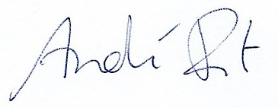

Name and Signature: André Ponte
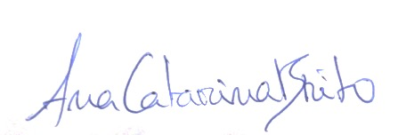

Name and Signature: Ana Brito

Name and Signature: Camila Nóbrega

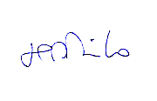

Name and Signature: Sofia Pinheiro

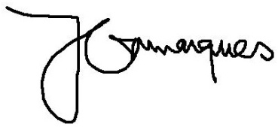
Name and Signature: João Gama Marques

