How allogeneic hematopoietic stem cell transplantation has evolved over time : 30-years’ experience at a single institution
Running title: 30-years of allogeneic transplantation at a single centre

Authors: Manuel Abecasis¹, Nuno Miranda¹, Isabelina Ferreira¹, Gilda Teixeira¹, Filipa Moita¹, Fernando Leal da Costa¹, Maria João Gutierrez¹, Carla Espadinha¹, Susana Esteves²
¹ Bone Marrow Transplantation Service, Instituto Português de Oncologia de Lisboa Francisco Gentil
² Clinical Research Unit, Instituto Português de Oncologia de Lisboa Francisco Gentil

Corresponding author: Manuel Abecasis, MD PhD
Bone Marrow Transplantation Service, Instituto Português de Oncologia de Lisboa Francisco Gentil, Rua Professor Lima Basto, 1099-023, Lisboa – Portugal
+351 21722 9864; mabecasis@ipolisboa.min-saude.pt

Competing interests statement: No competing interests to disclose.
How allogeneic hematopoietic stem cell transplantation has evolved over time: 30-year’s experience from a single institution
Resumo
Introdução
A transplantação alogénica de células hematopoiéticas é utilizada regularmente no tratamento de uma grande variedade de doenças hematológicas. O nosso programa de transplantação teve início em 1987 e desde então têm sido numerosos os avanços nesta área. Este estudo foi conduzido para avaliar se as alterações introduzidas ao longo de 30 anos melhoraram os resultados obtidos
Materiais e métodos
Analisámos os resultados numa população de 682 doentes submetidos consecutivamente a um 1º transplante alogénico entre 1987 e 2016. Para tal, os doentes foram divididos em intervalos de 10 anos e comparámos a sobrevida global (SG), a sobrevida livre de progressão (SLP), a mortalidade não associada a recaída (MNR) e as recaídas em cada década do estudo.
Resultados
A mediana de idades dos doentes transplantados, a utilização de células progenitoras provenientes do sangue periférico e a transplantação com dadores não familiares aumentaram muito significativamente ao longo do estudo. Verificou-se, comparativamente com a 1ª década, um aumento do número de doentes de alto risco nas duas décadas subsequentes. A mortalidade não relacionada com recidiva, avaliada aos 3 anos pós-transplante, diminuiu significativamente de 29% para 20% (P=0.045), mantendo-se estáveis a sobrevida global e a sobrevida livre de progressão, assim como a incidência cumulativa de recaídas.
Discussão
A transplantação alogénica hematopoiética tem evoluído consideravelmente desde a sua introdução na prática clinica. No presente trabalho são avaliados os reflexos dessa evolução ao longo de 30 anos sendo analisados os resultados obtidos e comparados com os referidos na literatura.
Conclusões
Apesar das características mais desfavoráveis verificadas ao longo das 3 décadas (doentes mais idosos, doenças de risco mais elevado, aumento do nº da dadores não familiares) foi possível reduzir significativamente a mortalidade associada ao procedimento, mantendo-se estáveis a sobrevida global e livre de progressão, assim como a incidência de recaídas.
ABSTRACT
Background
Allogeneic stem cell transplantation is an established procedure for a variety of diseases of the hematopoietic system. Our transplant program started in 1987 and since then advances have been made in the care of patients undergoing transplantation.
Objectives
We conducted a study to evaluate whether the changes implemented over time have improved the outcomes of transplantation.
Methods
We analyzed changes in patients, cell source, transplantation and outcome among 682 consecutive patients receiving their first transplant between 1987 and 2016. We compared overall survival (OS), progression-free survival (PFS), the incidence of non-relapse mortality (NRM) and relapse in 10-year cohorts over the study 3 decades.
Results
The median age of transplanted patients, the use of peripheral blood and unrelated donors all increased very significantly. There was an increase in the number of high-risk patients when comparing the first decade with the two subsequent ones. The 3-year nonrelapse mortality decreased significantly from 29% to 20% (P=0.045), while the overall survival, progression free survival and cumulative incidence of relapse remained stable.
Discussion
Allogeneic hematopoietic stem cell transplantation has evolved considerably since its introduction in the clinic. In the present study we evaluated how these changes affected our practice along 30 years of activity and compared the results with those published in the literature.
Conclusions
Despite increasing age, higher risk patients and the increasing use of unrelated donors our results show a continuous significantly reduced non relapse mortality, with stable overall survival, progression free survival and relapse rate.
INTRODUCTION
A wide variety of hematopoietic and non-hematopoietic diseases, ranging from hematologic malignancies to metabolic disorders and congenital or acquired bone marrow failures are successfully treated by allogeneic hematopoietic stem cell transplantation (HSCT).¹⁻⁴ In the early 1970s, toxicity from conditioning, infections, and graft-versus-host disease (GvHD) were associated with a significant risk of death, such that its application was the subject of some criticism.⁵ Over the past 50 years, advances in HLA-typing with better matching, better prophylaxis and treatment of frequent complications plus the introduction of reduced intensity conditioning regimens all have contributed to improve the results of HSCT, making it a safer procedure to be offered to a wider group of patients. ⁶⁻⁸
The purpose of this study was to compare transplant characteristics and results obtained over 30 years, since the beginning of our combined adult and pediatric transplant program in May 1987, the first to be conducted in Portugal and the longest in permanent activity.

PATIENTS AND METHODS
Patients
This retrospective study included 682 consecutive patients who underwent their first allogeneic HSCT between 1987 and 2016. The study was divided into three time periods (28/05/87 to 27/05/97; 28/05/97 to 27/05/07; 28/05/07 to 31/05/16). Data for this analysis were obtained from our patient database and collected from 28 May 1987 to 31 May 2016. The cut-off date for analysis was 31 May 2017. Survivors were censored at the date of last follow-up. Patients and donors gave permission for the use of their data and the study was approved by the institutional review board.
Transplantation techniques
All patients received a conditioning regimen followed by infusion of donor cells, mostly as inpatients in single rooms with HEPA filtered air. Although these regimens varied, the myeloablative conditioning (MAC) generally contained high-dose cyclophosphamide with busulfan or 12.0 to 13.2 Gy of total body irradiation (TBI). Reduced intensity regimens (RIC), introduced over the last 2 decades, were defined as in Bacigalupo et al⁹ and usually contained fludarabine with either 2Gy TBI, low dose busulfan or melphalan. Patients with acute leukemia (AL) in first complete remission (CR1), chronic myeloid leukemia (CML) in first chronic phase, aplastic anemia and non-malignant conditions were considered standard risk.¹⁰ Patients with AL beyond CR1, CML beyond 1st chronic phase, lymphomas and all malignancies in partial remission, progression or relapse were included in the high risk group. GvHD prophylaxis was with calcineurin inhibitors associated with methotrexate or mycophenolate mofetil, “in vivo” T cell depletion with ATG was added when using unrelated donors. Patients with an HLA C mismatch were given alemtuzumab instead of ATG to decrease the risk of graft rejection. ¹¹⁻¹² Prophylaxis against infections was with acyclovir, co-trimoxazole, oral quinolone and an azol antifungal agent. For cytomegalovirus (CMV) reactivation (on the basis of viral pp65 antigen or plasma DNA testing) preemptive therapy with ganciclovir was introduced in 1989. Since 1995, all patients received filgrastim from day +5 or +7 until the absolute neutrophil count reached 0.5x10⁹/L. Routine veno-occlusive prophylaxis was not used.
Outcome measures
Outcome measures included overall survival (OS), progression free survival (PFS), non-relapse mortality (NRM), GVHD related mortality, incidence of second malignancies and incidence of relapse. OS was defined as the time from the first allograft to death from any cause and PFS as the time from the first allograft to the first disease progression/relapse or death from any cause. NRM was defined as death after transplantation that was not preceded by a recurrence of the underlying disease. Data on these outcome measures reflect events as of the date of the last follow-up before the database was locked on 31 May, 2017.
Statistical analyses
We conducted a descriptive analysis of the clinical, demographic and transplant characteristics using absolute and relative frequencies for categorical variables and the median and range for quantitative variables. Variable comparison between the three transplant periods was carried out using the Pearson’s Chi-square test for categorical variables. In cases where an asymptotic test was not appropriate (cells with expected frequency below 5) we conducted a Chi-squared test with simulated p-value based on 2000 replicates. For quantitative data, comparisons were performed using the Kruskal-Wallis test.
OS and PFS were calculated using the Kaplan-Meier method and the log-rank test for group comparison. Non-relapse mortality, GVHD related mortality, incidence of secondary malignancies and incidence of relapse were calculated using the cumulative incidence procedure for competing risk models and the Gray test for group comparison. All tests were two-sided and a significance level of 5% was considered. All analyses were done using the R package.¹³

RESULTS
Patients and transplant characteristics
During the study period 682 consecutive patients received a first allogeneic transplant. Patient disease and transplantation characteristics are detailed in Table 1. When compared across the 3 decades, the median age of pediatric patients remained stable (p=0.376) as opposed to adult patients whose age increased significantly over the study period (p<0.001).
The percentage of unrelated donations increased significantly over the 3 decades; as for the source of stem cells, bone marrow was the preferred source during the first decade , but decreased over the two subsequent periods (p<0.001).
Umbilical cord blood was started in 1994 and a total of 38 patients (6%) were transplanted with this source during the time period of the study, either from an unrelated donor or from family-directed cord blood. ¹⁴
Conditioning regimens varied according to transplant period (Table 1). The percentage of patients given a MAC conditioning decreased significantly from 87% the first decade to 72% in the last decade (p<0.001).
The use of ATG in the conditioning regimen increased significantly over the study period (p<0.001).
Since November 2014, 10 patients (8 Hodgkin’s disease and 2 AML) were given unmanipulated haploidentical transplants. Hodgkin’s disease patients were conditioned with the Baltimore protocol¹⁵ and the others with the Genoa protocol¹⁶ The proportion of patients with non-malignant conditions (aplastic anemia, hemoglobinopathies, inborn errors of metabolism, osteopetrosis, hereditary bone marrow failure syndromes, primary immunodeficiency syndromes) remained stable over the 3 decades, accounting for 15% of the total number of transplants. Furthermore, a shift in indications for HSCT in hematologic malignancies, away from CML and ALL and towards AML and lymphomas, could be observed.
With regards to disease status at transplantation there was a significant rise of high-risk patients being transplanted, from the first to the subsequent decades (p=0.024).

Clinical outcomes
The median follow-up for surviving patients in first decade was 23 years, in the second 13 years and in the last decade 3.5 years. Of the 682 patients, 45% died and 55% are still alive at the time of last follow-up with a 3-year OS of 59%. The OS at 3-years for the patients transplanted with a related donor was 60% and for those who had an unrelated transplant was 59% (p=0.643) (Figure 1A).
Among those receiving an unrelated transplant, 105 had an HLA identical match (number of alleles tested 6, 8 or 10, depending on the time frame of the transplant), 110 had a 1 allele mismatched donor and 22 a donor with > 1 mismatch. The 3-year OS for the latter patients was significantly worse than for the other 2 groups (36% versus 57% and 65% respectively, p=0.036) (Figure 1B).
The 3-year OS in the decade 1897-1997 was 58%, 55% in the second decade and rose to 64% in the last decade with no significant differences among the 3 time periods (Figure 1C). The PFS at 3 years in the first period was 51%, 49% in the second period with a trend towards better results in the third period (56%) (p=0.124).
CML patients transplanted in the last decade do not seem to have a worse survival when compared to those treated in previous decades (Figure 1D).
The day 100 NRM was 12% on each of the first 2 decades with a non-significant decrease to 9% in the last decade of the study.
When comparing the 3-year cumulative incidence of NRM among the 3 decades there was a significant improvement in the results observed over the time period of the study, being respectively 28%, 24% and 19% over each of the 3 time periods (p=0.045) (Figure 1E).
The 3-year cumulative mortality associated with GVHD as a whole (acute and chronic) was 8.5% in the first decade, 11.2% in the second decade and 7.6% in the last period (p=0.320, Figure 1F).
The cumulative incidence of relapse/progression at 3-years was 27%. It remained relatively stable throughout the 3 decades (Figure 2A).
We could not demonstrate any significant difference between RIC and MAC conditioning regarding the cumulative incidence of relapse (Figure 2B).
The cumulative incidence of secondary malignancies in the overall population rose from 0.95% at 3 years to 4.42% at 15 years, with a similar incidence in the first and second decades (Figure 3). There were 10 cases of basal cell carcinoma, 4 head and neck cancers, 4 melanomas, 3 breast cancers, 2 thyroid cancers and 1 each of bladder carcinoma and liver adenocarcinoma. One further patient developed a diffuse large B cell lymphoma and another, originally transplanted for severe aplastic anemia, developed acute myeloid leukemia of donor cell origin.

Causes of death
Three hundred and ten patients died during the period of the study and the causes of death are detailed in Table 2. Relapse accounted for 138 of the deaths, and 169 were due to HSCT related complications, including 4 graft rejections. With longer follow-up, other causes of death were observed, such as cardiovascular disorders (1 myocardial infarction, 3 strokes) and other malignancies (4 oral cavity/pharynx, 1 bladder carcinoma, 1 hepatic adenocarcinoma, 1 Ewing sarcoma and 1 inoperable cavernous sinus meningioma).
There were 2 suicides among our patients, and one fatal traffic accident.

DISCUSSION
During the past decades HSCT has changed considerably with respect to patient clinical diagnosis, choice of donor, stem cell source, conditioning regimens, and several other measures destined to reduce and treat transplant related complications. Although we have been running an autologous and allogeneic transplant program, for both pediatric and adult patients, the present study only includes consecutively transplanted patients given a first allogeneic transplant, from May 1987 to May 2016.
The entire population is composed of 682 patients and all of them, with the exception of 3 cases lost to follow-up, were followed-up until the time of death or the last yearly visit since transplantation, allowing us to have a broader view of the long term outcome of our patient population.
The total number of transplanted patients increased in each decade and they tended to be transplanted with more advanced disease. The adult patients’ age increased significantly (p<0.001). Peripheral blood stem cells became the preferred stem cell source for transplant (although in the last decade we saw an increase in the number of bone marrow donations) and in the last decade unrelated donors clearly outnumbered family donors (p<0.001). This is probably related to the success of the donor registries in recruiting more donors, (the Portuguese registry has increased its number of donors from 1 500 to nearly 400 000 over the last 15 years) and to advances in HLA typing allowing for a better selection of unrelated donors. This may contribute to the improved survival reported in several studies, with similar outcomes among transplantations from HLA matched related or 10/10 allele-matched unrelated donors, or even 9/10 unrelated donors, as is our experience in this study. ¹⁷⁻¹⁹ The 3-year OS of our patients transplanted with an unrelated donor was 59%, which is identical to the 60% observed in those transplanted with a related donor; no difference in OS was seen between patients transplanted with an HLA identical unrelated donor and those whose donors had a single HLA mismatch. The outcome for 9/10 unrelated transplants is still a matter of controversy with some authors reporting inferior OS when compared to 10/10 unrelated transplants and others reporting similar results in terms of OS, GvHD, TRM and relapse. ¹⁷⁻²⁰ Differences in conditioning regimens (use of ATG, MAC versus RIC), GvHD prophylaxis, disease diagnosis and stage at transplant are possible explanations for this discrepancy. ¹⁷⁻²¹
Major developments in hemato-oncology translated into variations in the disease profile of the patients treated in our program. Presently, CML patients needing a transplant are those who fail tyrosine kinase inhibitors (TKIs) treatment or present in accelerated or blast crisis, with a decline of patients transplanted for CML. This may start to increase as the prevalence of CML increases, and patients resistant to TKIs will likely require HSCT. ²²⁻²⁴ One would expect a worse survival for these patients but our preliminary results indicate a similar PFS for patients transplanted in the TKI era. These results are in keeping with recent reports. ²²⁻²⁴ We have also seen a reduction in the number of patients transplanted for ALL, particularly children, reflecting the improvement in the modern chemotherapy protocols and the introduction of the minimal residual disease concept, whose negativity has become the target of the more recent protocols. ²⁵ Conversely, the number of transplants for AML patients rose significantly and this is probably multifactorial, namely better supportive care during induction chemotherapy allowing for more patients being brought to transplant, better definition of patients who may benefit from a transplant, acceptance of older patients in our program and the availability of better well matched unrelated donors. Although the numbers are small we also saw an increase in the numbers of patients transplanted for lymphomas, from 6% of all lymphoid malignancies in the first decade to 41% in the third decade. This is in line with the recent trend observed in the most recent EBMT survey analysis. ²⁶
Even though the number of patients given a MAC conditioning was significantly reduced over time (p<0.001), with a consequent increase in patients given a RIC conditioning, this was only reflected in a small, non-significant increase in the relapse rate of hematologic malignancies over the study period. These results are not in agreement with previous reports but different characteristics among the patients treated in different studies may explain different outcomes. ⁸
The causes of death varied in the study period. In the first decade, disease relapse and HSCT related causes accounted respectively for 31% and 69% of the deaths whereas in the last decade each of these causes was responsible for 51% and 49% of the deaths.
The 3-year OS remained stable over the study period. However the characteristics of the population treated changed, with significantly more unrelated transplants and older patients being treated. Still, the cumulative incidence of GvHD-related mortality was not significantly different in the 3 decades; however the NRM due to other transplant-related complications decreased significantly over time even though older patients, more advanced disease stages and an increased number of unrelated transplants were performed.
Reduction in NRM has been a consistent finding in recently published studies from several centers that retrospectively compared results obtained over chronologically different periods of allogeneic HSCT activity. Our results are concordant with these reports. ²⁷⁻³³
Dealing with relapse continues to be a challenge after HSCT as it is now the major cause of treatment failure. New approaches are available such as TKIs targeting Flt3-internal tandem duplication in AML, either alone or in combination with hypomethylating agents. ³⁴⁻³⁹ Monoclonal antibodies and antibody-drug conjugates are also being investigated, with blinatumomab being active in relapsed ALL and used either alone or in conjunction with DLI. ⁴⁰ Checkpoint inhibitors represent another possible approach for relapse treatment but they may lead to significant GvHD. ⁴¹⁻⁴² Genetically engineered T cells are a powerful class of therapeutic agents with several clinical trials showing responses in patients with relapsed, refractory, B-cell malignancies. ⁴³⁻⁴⁴
Conclusions
This study shows the changes and progresses that have occurred in our daily practice of allogeneic HSCT, outside of clinical trials. These developments have allowed us to offer allogeneic transplantation to older patients, patients with comorbidities or more advanced disease and to those without related donors. We observed a statistically significant improvement in NRM over time, despite treating patients with a less favorable prognosis. We believe that allogeneic HSCT will remain a valuable treatment option for patients with malignant and non-malignant diseases and with continuous improvement of results a safer treatment option.

ACKNOWLEDGEMENTS
We thank the following physicians I. Nolasco, A. Guimarães, J.L. Passos Coelho, A. Machado, E Fernandez, the nursing staff for their dedicated patient care and M. Cunha for helping in data collection. MA thanks Professors M. Mohty and J. Melo for reviewing the manuscript. We also thank the Liga Portuguesa Contra o Cancro and the Fundação Calouste Gulbenkian for their support in setting up the transplant program.

CONFLICT OF INTEREST
There are no conflicts of interest to report.

REFERENCES
- Copelan EA. Hematopoietic stem-cell transplantation. N Engl J Med. 2006; 354: 1813-1826.
- Thomas E, Storb R, Clift RA, Fefer A, Johnson L, Neiman P et al. Bone-marrow transplantation. N Engl J Med. 1975; 292: 832-843.
- Thomas E, Storb R, Clift RA, Kohnson L, Neiman P et al. Bone-marrow transplantation. N Engl J Med. 1975; 292: 895-902.
- Mathé G, Amiel JL, Schwarzenberg L, Cattan A, Schneider M, Devries MJ et al. Successful allogeneic bone marrow transplantation in man: chimerism, induced specific tolerance and possible anti-leukemic effects. Blood 1965; 25: 179-196.
- Bortin MM. A compendium of reported human bone marrow transplants. Transplantation 1970; 9: 571-587.
- Appelbaum FR. Hematopoietic-cell transplantation at 50. N Engl J Med. 2007; 357: 1472-1475.
- Lee SJ, Klein J, Haagenson M, Baxter-Lowe LA, Confer DL, Eapen M et al. High-resolution donor-recipient HLA matching contributes to the success of unrelated donor marrow transplantation. Blood 2007; 110: 4576-4583.
- Storb R, Sandmaier BM. Nonmyeloablative allogeneic hematopoietic cell transplantation. Haematologica 2016; 101: 521-530.
- Bacigalupo A, Ballen K, Rizzo D, Giralt S, Lazarus H, Ho V et al. Defining the intensity of conditioning regimens: working definitions. Biol Blood Marrow Transplant. 2009; 15: 1628-1633.
- Chaidos A, Kanfer E, Apperley JF. Risk assessment in haematopoietic stem cell transplantation: disease and disease stage. Best Pract Res Clin Haematol. 2007; 20: 125-154.
- Petersdorf EW, Longton GM, Anasetti C, Mickelson EM, McKinney SK, Smith AG et al. Association of HLA-C disparity with graft failure after marrow transplantation from unrelated donors. Blood 1997; 89: 1818-1823.
- Pierdomenico F, Ferreira I, Teixeira G, Miranda N, Guimarães A, Fernandez E, Abecasis, M. The role of Campath in HLA-C mismatched unrelated allogeneic transplant: a single center experience. Bone Marrow Transplant. 2011; 46: S358.
- R Core Team (2014). R: A language and environment for statistical computing. R Foundation for Statistical Computing, Vienna, Austria. (URL http://www.R-project.org/)
- Abecasis M, Gutierrez MJ, Espadinha C et al. Clinical utility of family-directed cord blood storage. Presented at: V World Cord Blood Congress and Innovative Cell Therapies, Monaco, 5-8 March 2015.
- Luznick L, O’Donnell PV, Symons HJ, Chen AR, Leffell SM, Zahurak M et al. HLA-haploidentical bone marrow transplantation for hematologic malignancies using nonmyeloablative conditioning and high-dose posttransplantation cyclophosphamide. Biol Blood Marrow Transplant. 2008; 14: 641-650.
- Raiola AM, Dominietto A, Ghiso A, Di Grazia C, Lamparelli T, Gualandi F et al. Unmanipulated haploidentical bone marrow transplantation and posttransplantation cyclophosphamide for hematologic malignancies after myeloablative conditioning. Biol Blood Marrow Transplant. 2013; 19: 117-122.
- Horowitz M. Does matched unrelated donor transplantation have the same outcome as matched sibling transplantation in unselected patients? Best Pract Res Clin Haematol. 2012; 25: 483-486.
- Kroger N, Zabelina T, Binder T, Ayuk F, Bacher U, Amtsfeld G et al. HLA-mismatched unrelated donors as an alternative graft source for allogeneic stem cell transplantation after antithymocyte globulin-containing conditioning regimen. Biol Blood Marrow Transplant. 2009; 15: 454-462.
- Jorge AS, Suárez-Lledó M, Pereira A, Gutierrez G, Fernandez-Avilez F, Rosiñol L et al. Single antigen-mismatched unrelated hematopoietic stem cell transplantation using high-dose post-transplantation cyclophosphamide is a suitable alternative for patients lacking HLA-matched donors. Biol Blood Marrow Transplant. 2018; 24:1196 1202.
- Michallet M, Sobh M, Serrier C, S Morisset, Labussière H, Ducastelle S et al. Allogeneic hematopoietic stem cell transplantation for hematologic malignancies from mismatched 9/10 human leukocyte antigen unrelated donors: comparison with transplants from 10/10 unrelated donors and human leukocyte antigen identical siblings. Leuk Lymphoma 2015; 56: 999-1003.
- Granier C, Biard l, Masson E, Porcher R, Peffault de Latour R, Robin M et al. Impact of the source of hematopoietic stem cell in unrelated transplants: Comparison between 10/10, 9/10 HLA-matched donors and cord blood. Am J Hematol. 2015; 90: 897-903.
- Jabbour E, Kantarjian H. Chronic myeloid leukemia: 2018 updates on diagnosis, therapy and monitoring. Am J Hematol. 2018; 93: 442-459.
- Nair AP, Barnett MJ, Broady RC, Hogge DE, Song KW, Toze CL et al. Allogeneic hematopoietic stem cell transplantation is an effective salvage therapy for patients with chronic myeloid leukemia presenting with advanced disease or failing treatment with tyrosine kinase inhibitors. Biol Blood Marrow Transplant. 2015; 21: 1437-1444.
- Lee S, Choy SY, Kim SH, Jang EJ, Bang JH, Byeun JY et al. Prognostic factors for outcomes of allogeneic stem cell transplantation in chronic phase chronic myeloid leukemia in the era of tyrosine kinase inhibitors. Hematology 2014; 19: 63-72.
- Bruggemann M, Gokbuget N, Kneba M. Acute lymphoblastic leukemia: monitoring minimal residual disease as a therapeutic principle. Semin Oncol. 2012; 39: 47-57.
- Passweg JR, Baldomero H, Bader P, Basek GW, Bonini C, Duarte R et al. Is the use of unrelated donor transplantation leveling off in Europe? The 2016 European Society for Blood and Marrow Transplant activity survey report. Bone Marrow Transplant. 2018; 53:1139-1148.
- Gooley TA, Chien JW, Pergam SA, Hingorani S, Sorror ML, Boeckh M et al. Reduced mortality after allogeneic hematopoietic-cell transplantation. N Engl J Med. 2010; 363: 2091-2101.
- Remberger M, Ackefors M, Berglund S, Blennow O, Dahllof G, Dlugosz A et al. Improved survival after allogeneic hematopoietic stem cell transplantation in recent years. A single-center study. Biol Blood Marrow Transplant. 2011; 17: 1688-1697.
- Hahn T, McCarthy PL, Hassebroek A, Bredeson C, Gajewski JL, Hale GA et al. significant improvement in survival after allogeneic hematopoietic cell transplantation during a period of significantly increased use, older recipient age, and use of unrelated donors. J Clin Oncol. 2013, 31: 2437-2449.
- Mateos MK, O’Brien TA, Oswald C, Gabriel M, Ziegler DS, Cohn RJ et al. Transplant-related mortality following allogeneic hematopoietic stem cell transplantation for pediatric acute lymphoblastic leukemia. 25-year retrospective review. Pediatr Blood Cancer 2013; 60: 1520-1527.
- Malard F, Chevalier P, Guillaume T, Delaunay J, Rialland F, Harousseau JL et al. Continuous reduced nonrelapse mortality after allogeneic hematopoietic stem cell transplantation: a single-institutuion’s three decade experience. Biol Blood Marrow Transplant. 2014; 20: 1217-1223.
- O’Meara A. Holbro A, Meyer S, Martinez M, Buser A, Halter J et al. Forty years of hematopoietic stem cell transplantation: a review of the Basel experience. Swiss Med Wkly. 2014; 144: w13928.
- Brissot E, Rialland F, Cahu X, Strullu M, Corradini N, Thomas C et al. Improvement of overall survival after allogeneic hematopoietic stem cell transplantation for children and adolescents: a three-decade experience of a single institution. Bone Marrow Transplant. 2016; 51: 267-272.
- Soiffer R, Chen YB. Pharmacologic agents to prevent and treat relapse after allogeneic hematopoietic cell transplantation. Blood Adv. 2017; 1: 2473-2482.
- Stone RM, Mandrekar SJ, Sanford BL, Laumann K, Geyer S, Bloomfield CD et al. Midostaurin plus chemotherapy for acute myeloid leukemia with a FTL3 mutation. N Engl J Med. 2017; 377: 454-464.
- Battipaglia G, Ruggeri A, Massoud R, Cheikh EI, Jestin M, Antar A et al. Efficacy and feasibility of sorafenib as a maintenance agent for fms-like tyrosine kinase-3 mutated acute myeloid leukemia. Cancer 2017; 123: 2867-2874.
- Sid S, Rey J, Charbonnier A, D’Incan, Mohty B, Blaise D et al. Treatment of post-transplant relapse of FLT3-ITD mutated AML using 5-Azacytidine and sorafenib bittherapy. Clin Lymphoma Myeloma Leuk. 2017; 17: 241-242.
- Rautenberg C, Hachtkamp K, Dienst A, Schmidt PV, Heyn C, Kondakci M et al. Sorafenib and azacytidine as salvage therapy for relapse of FLT3-ITD mutated AML after allo-SCT. Eur J Haematol. 2017; 98: 348-354.
- De Freitas T, Marktel S, Piemontese S, Carrabba MG, Tresoldi C, Messina C et al. High rates of hematological response to sorafenib in FLT3-ITD acute myeloid leukemia relapsed after allogeneic hematopoietic stem cell Transplantation. Eur J Haematol. 2016; 96: 629-636.
- Ueda M, de Lima M, Caimi P, Tomlinson B, Little J, Creger R et al. Concurrent blinatumomab and donor lymphocyte infusions for treatment of relapsed pre-B-cell ALL after allogeneic hematopoietic cell transplant. Bone Marrow Transplant. 2016; 51: 1253-55.
- Haverkos BM, Abott D, Hamadani M, Armand P, Flowers ME, Merryman R et al. PD-1 blockade for relapsed lymphoma post-allogeneic hematopoietic cell transplantation: high response rates but frequent GvHD. Blood 2017; 130: 221-228.
- Gokbuget N, Canaani J, Nagler A, Bishop M, Kroger N, Avigan D. Prevention and treatment of relapse after stem cell transplantation with immunotherapy. Bone Marrow Transplant. 2018; 53: 664-672.
- Dietz AC, Wayne AS. Cells to prevent/treat relapse following allogeneic stem cell transplantation. Hematology Am Soc Hematol Educ Program 2017; 708-715.
- June CH, Sadelain M. Frontiers in Medicine series: Chimeric antigen receptor therapy. N Engl J Med. 2018; 379: 64-73.

FIGURE LEGENDS

Figure 1. Outcomes after allotransplant. (A) Overall survival by donor type in overall sample. (B) Overall survival by HLA allele mismatch in unrelated donor transplants. (C) Overall survival by transplant period in overall sample. (D) Overall survival by transplant period in CML patients (E) Cumulative incidence of Non-Relapse Mortality by transplant period in overall sample. (F) Cumulative incidence of GvHD mortality by transplant period in overall sample

Figure 2. (A) Cumulative incidence of relapse by transplant period in patients with hematological malignancies. (B) Cumulative incidence of relapse by conditioning regimen in patients with hematological malignancies.

Figure 3. Cumulative incidence of secondary malignancy by transplant period in overall sample.

TABLES
Table 1. Patient and first allotransplant characteristics by decade
Characteristic, n(%) | All | 1st decade  1987-1997 | 2nd decade  1997-2007 | 3rd decade  2007-2016 | P¹
No. of first allotransplants  Pediatric patients  Adult patients | 682  271  411 | 164  72  92 | 232  94  138 | 286  105  181 | ---
Patient age (years), Median (range)  All patients  Pediatric patients  Adult patients | 26 (0.3-67)  8 (0.3-18)  38 (19-67) | 22 (0.5-53)  8 (0.5-18)  31 (19-53) | 26 (0.3-58)  7 (0.3-17)  37 (20-58) | 33 (0.4-67)  8 (0.4-18)  42 (19-67) | <0.001  0.376  <0.001
Patient sex  Female  Male | 292 (43%)  390 (57%) | 59 (36%)  105 (64%) | 98 (42%)  134 (58%) | 135 (47%)  151 (53%) | 0.067
Diagnosis  Myeloid malignancies  AML  CML  MDS/CMML  MPN  Other²  Lymphoid malignancies  ALL  Lymphoma  CLL  MM  Other³  Bone marrow aplasia  Immunodeficiency disorders  Hemoglobinopathies  Metabolic disorders  Other | 339 (50%)  187 (55%)  96 (28%)  36 (11%)  2 (1%)  18 (5%)  242 (35%)  152 (63%)  66 (27%)  11 (5%)  8 (3%)  5 (2%)  63 (9%)  19 (3%)  11 (2%)  7 (1%)  1 (<1%) | 92 (56%)  39 (42%)  46 (50%)  5 (5%)  1 (1%)  1 (1%)  47 (29%)  39 (83%)  3 (6%)  2 (4%)  1 (2%)  2 (4%)  21 (13%)  1 (1%)  1 (1%)  2 (1%)  0 | 111 (48%)  52 (47%)  39 (35%)  13 (12%)  1 (1%)  6 (5%)  97 (42%)  66 (68%)  23 (24%)  3 (3%)  3 (3%)  2 (2%)  13 (6%)  3 (1%)  4 (2%)  3 (1%)  1 (<4%) | 136 (48%)  96 (71%)  11 (8%)  18 (13%)  0  11 (8%)  98 (34%)  47 (48%)  40 (41%)  6 (6%)  4 (4%)  1 (1%)  29 (10%)  15 (5%)  6 (2%)  2 (1%)  0 | 0.001  0.002
Disease status  High risk  Standard risk | 314 (46%)  368 (54%) | 62 (38%)  102 (62%) | 120 (52%)  112 (48%) | 132 (46%)  154 (54%) | 0.024
Donor type  Related  Unrelated  HLA matching  Matched  Other | 445 (65%)  237 (35%)  105 (44%)  132 (56%)) | 160 (98%)  4 (2%)  2 (50%)  2 (50%) | 166 (72%)  66 (28%)  28 (42%)  38 (58%) | 119 (42%)  167 (58%)  77 (46%)  90 (54%) | <0.001  0.188
Stem cell source  Bone marrow  PBSC  CB | 325 (48%)  319 (47%)  38 (6%) | 156 (95%)  2 (1%)  6 (4%) | 63 (27%)  148 (64%)  21 (9%) | 106 (37%)  169 (59%)  11 (4%) | <0.001
Conditioning regimen⁴  Myeloablative  Reduced-intensity conditioning | 532 (78%)  149 (22%) | 143 (87%)  21 (13%) | 185 (80%)  47 (20%) | 204 (72%)  81 (28%) | <0.001
TBI-based conditioning  No  Yes | 541 (79%)  141 (21%) | 138 (84%)  26 (16%) | 189 (81%)  43 (19%) | 214 (75%)  72 (25%) | 0.039
ATG-based conditioning  No  Yes | 484 (71%)  198 (29%) | 152 (93%)  12 (7%) | 170 (73%)  62 (27%) | 162 (57%)  124 (43%) | <0.001
¹ Overall comparison of the three transplant periods;
² Other myeloid malignancies includes myelofibrosis (n=10), undifferentiated AL (n=6) and dendritic cell leukemia (n=2)
³ Other lymphoid malignancies includes Burkitt lymphoma (n=4) and plasma cell leukemia (n=1)
⁴ Missing in one patient who received first allotransplant in the period of 2007-2016.

Caption:
AML, acute myeloid leukemia; CML, chronic myeloid leukemia; MDS, myelodysplastic syndrome; CMML, chronic myelo monocytic leukemia; MPN, myeloproliferative neoplasm; ALL, acute lymphoblastic leukemia; CLL, chronic lymphocytic leukemia; MM, multiple myeloma; PBSC, peripheral blood stem cells; CB, cord blood; TBI, total body irradiation; ATG, antithymocyte globulin

Table 2. Causes of death
 | All patients | 1987 – 1997 | 1997 – 2007 | 2007 - 2016
N | 310 | 84 | 119 | 107
Relapse/Progression | 138 (45%) | 26 (31%) | 58 (49%) | 54 (51%)
HSCT related causes | 169 (55%) | 57 (69%) | 59 (50%) | 53 (49%)
Infection | 30 | 7 | 11 | 12
GVHD | 63 | 16 | 27 | 20
VOD | 6 | --- | 3 | 3
Other organ toxicity¹ | 58 | 28 | 15 | 15
2nd malignancy | 8 | 4 | 1 | 3
Rejection | 4 | 2 | 2 | -
External causes of death² | 3 | 1 | 2 | -
¹ Includes: stroke (3), myocardial infarction (1)
² Includes: suicide (2), accident (1)
FIGURES
Figure 1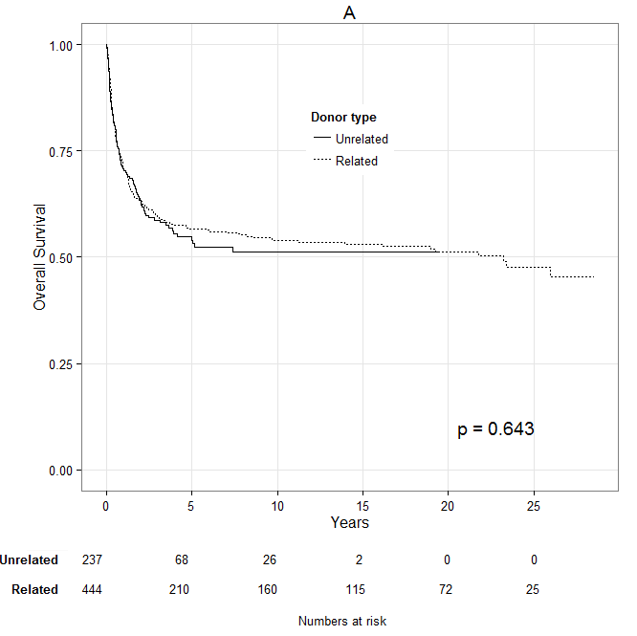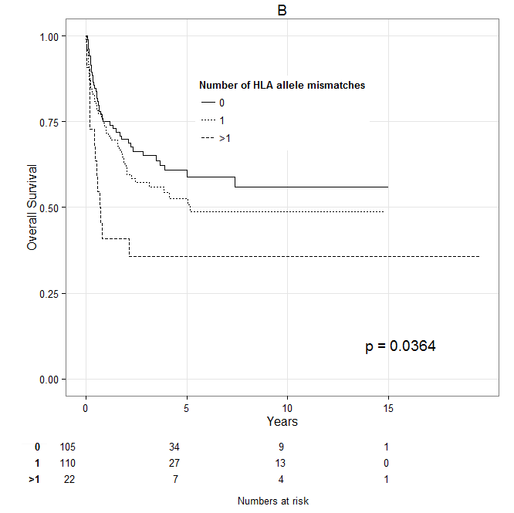
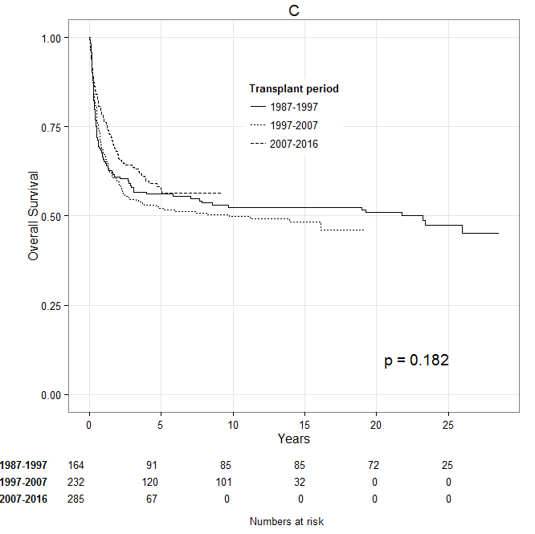
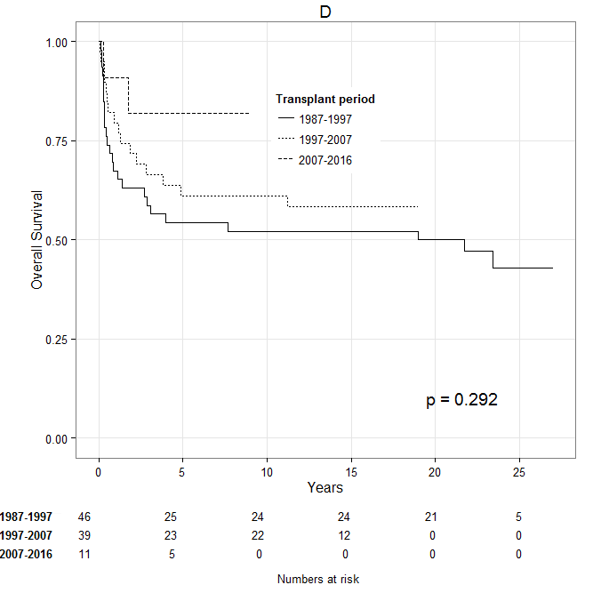
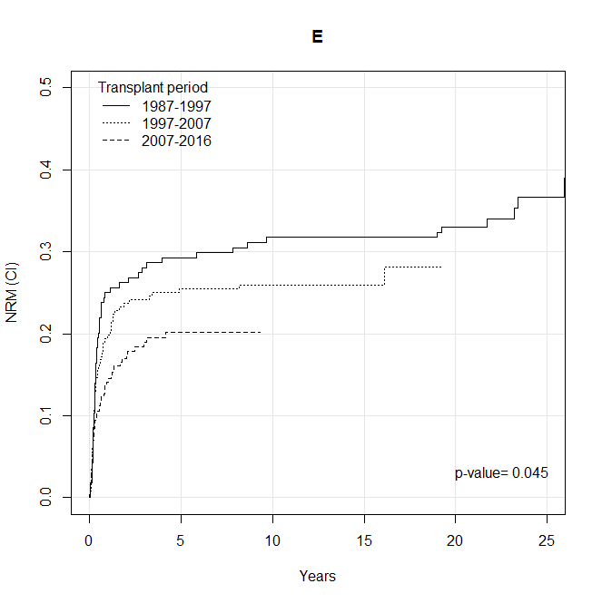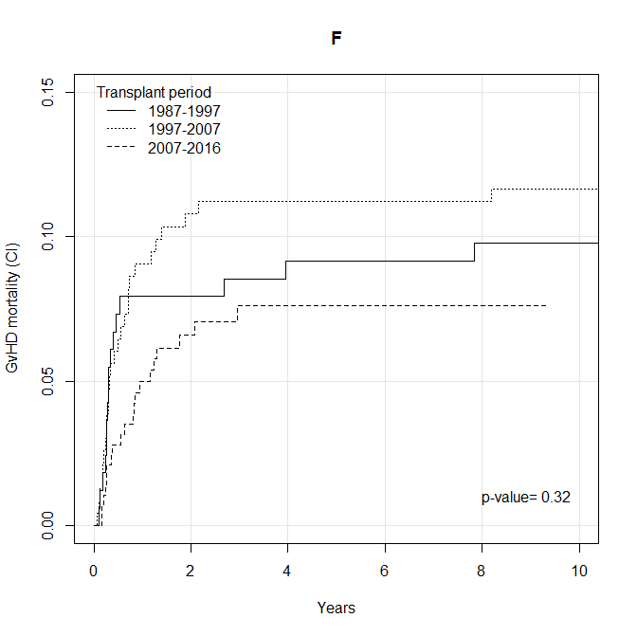
Figure 2
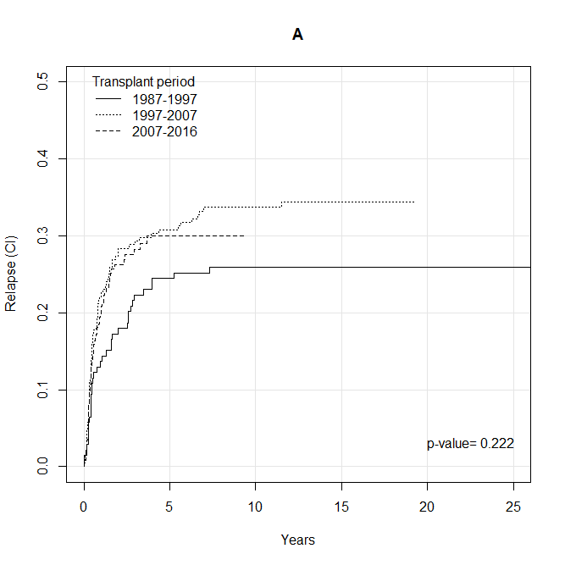
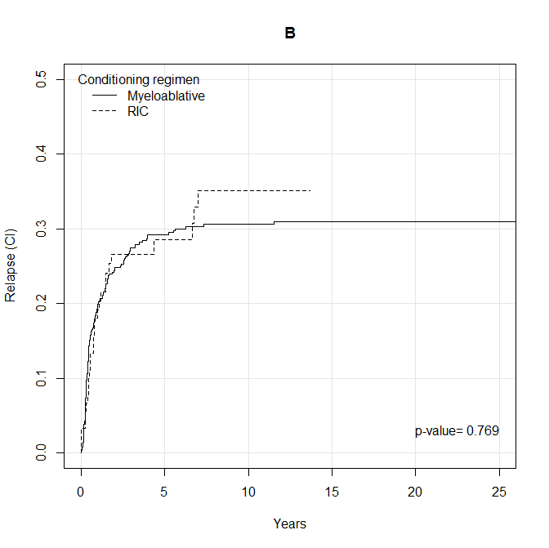
Figure 3
