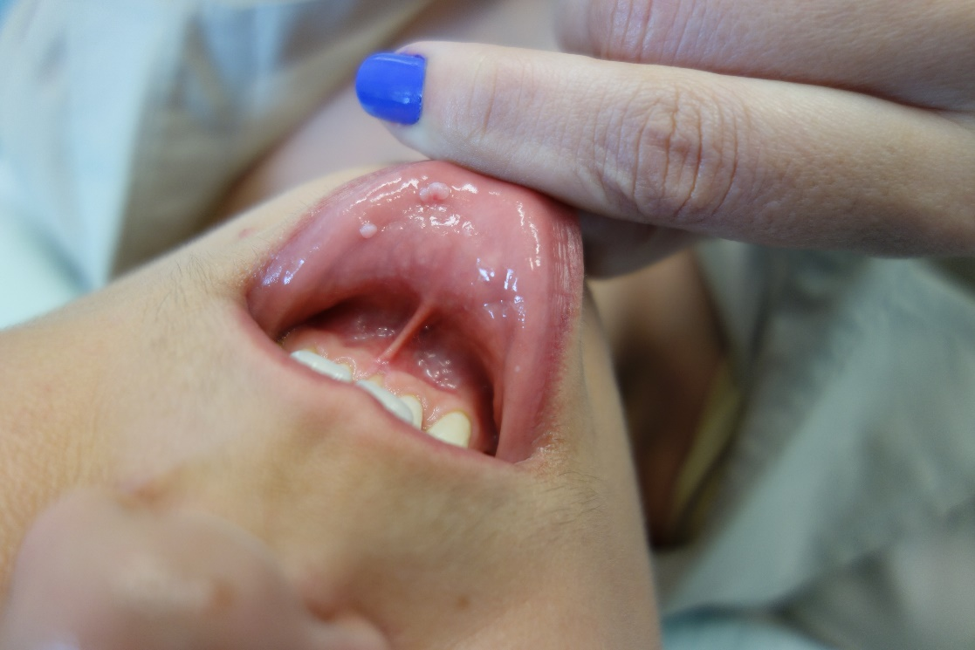
Figure 1: HPV infection of the oral cavity: two condilomas in the inner lower lip.

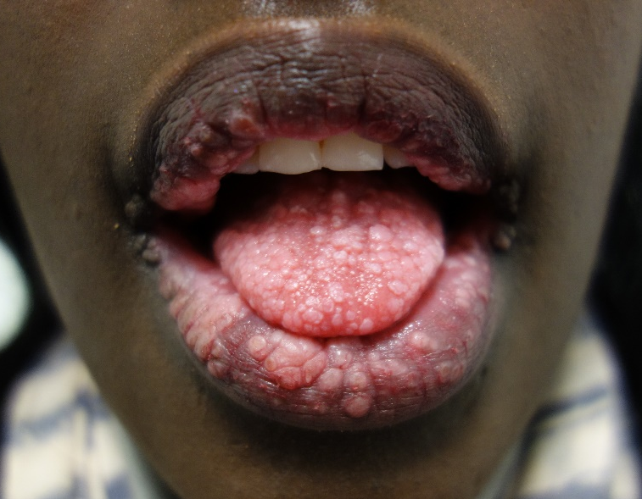
Figure 2: HPV infection of the oral cavity with multiple condylomata acuminata in an HIV-infected patient.

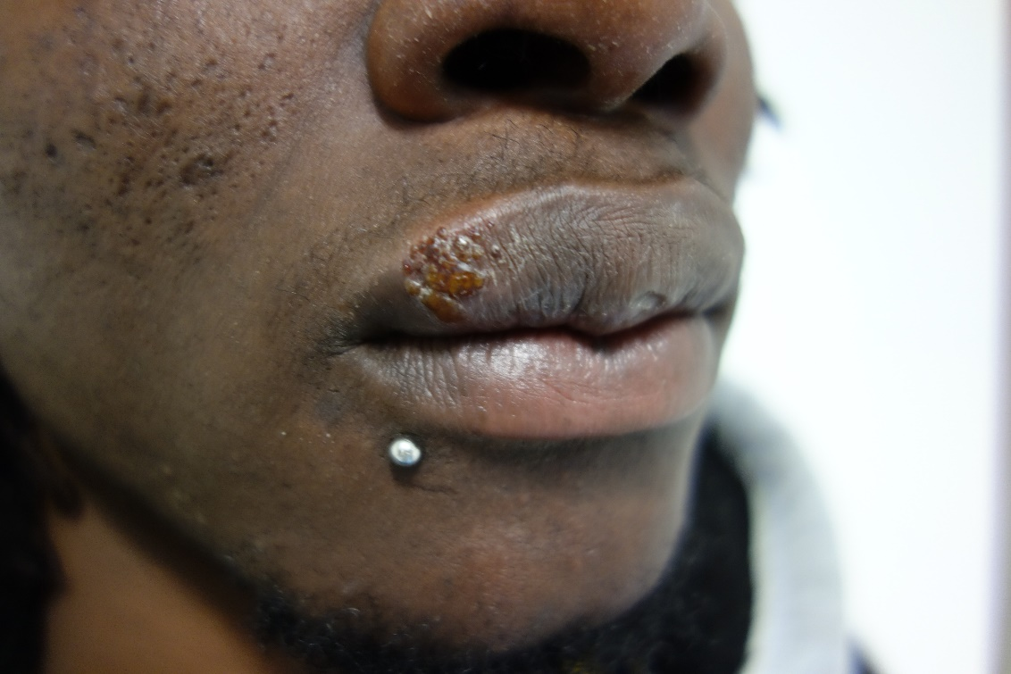
Figure 3: Herpes simplex infection of the upper lip. In this patient, HSV-2 was identified by polymerase chain reaction.

Figure 4 – Syphilis in the oral cavity: A - primary chancre in the palate; B - condylomata lata on the side of the tongue.

