RESEARCH PAPER

TITLE: Paediatric multiple sclerosis lesion burden and activity on magnetic resonance imaging: a pilot, retrospective and comparative study with a population of adult patients (COMPARE-MS)

TÍTULO: Atividade e carga lesional em ressonância magnética na Esclerose Múltipla pediátrica: estudo piloto, retrospetivo e comparativo com uma população de doentes adultos (COMPARE-MS)

RUNNING TITLE: A comparative study of paediatric and adult multiple sclerosis (COMPARE-MS)

Authors: Sara de Carvalho¹, Joana Pinto², Inês Correia³, Ricardo Faustino^{4,5}, Mónica Vasconcelos⁶, Lívia Sousa³, Filipe Palavra^{1,6,7}*

Affiliations:
1. Coimbra Institute for Clinical and Biomedical Research (iCBR), Faculty of Medicine, University of Coimbra, Coimbra, Portugal
2. Medical Imaging Department, Neuroradiology Unit, Centro Hospitalar e Universitário de Coimbra, Coimbra, Portugal
3. Neurology Department, Centro Hospitalar e Universitário de Coimbra, Coimbra, Portugal
4. Institute of Biophysics and Biomedical Engineering, Faculty of Sciences, University of Lisboa, Lisboa, Portugal
5. Superior Health Institute Ribeiro Sanches, Lisboa, Portugal
6. Centre for Child Development – Neuropediatrics Unit, Hospital Pediátrico, Centro Hospitalar e Universitário de Coimbra, Coimbra, Portugal
7. CNC.IBILI, University of Coimbra, Coimbra, Portugal

*Correspondence:
Filipe Palavra
Centre for Child Development – Neuropediatrics Unit, Hospital Pediátrico, Centro Hospitalar e Universitário de Coimbra
Avenida Afonso Romão, 3000-602 Coimbra
Portugal
fpalavra@fmed.uc.pt

Paediatric multiple sclerosis lesion burden and activity on magnetic resonance imaging: a pilot, retrospective and comparative study with a population of adult patients (COMPARE-MS)

ABSTRACT

Introduction: Paediatric-onset multiple sclerosis (POMS) may contrast with adult-onset MS (AOMS). We aimed to determine differentiating features between POMS and AOMS, at diagnosis and after 1 year under DMT, and analyse between groups the reaching the status of “No Evidence of Disease Activity” (NEDA-3).
Methods: We analyzed demographical, laboratorial, clinical and imaging features of patients with relapsing-remitting MS diagnosed at our center, according to the McDonald’s 2010 criteria, with ≥1 year under DMT and with available magnetic resonance imaging (MRI) scans at diagnosis and 1 year after DMT initiation. Patients were paired according to gender and DMT in use. NEDA-3 status was assessed and differences studied.
Results: Fifteen POMS (aged ≥8 and <18 years) and 15 AOMS (≥18 and <55 years) patients were recruited. We found a statistically significant difference in the number of T2 weighted image diffuse lesions/with poorly defined borders (p=0.015). The mean Expanded Disability Status Scale (EDSS) score after 1 year under DMT was lower in the POMS group (1.6±0.8) compared to the AOMS group (2.3±0.8; p=0.032). Compared to patients under natalizumab, patients under interferons as DMT presented a 12 time-fold higher probability of not achieving the NEDA-3 status (p=0.029).
Conclusion: Although there is an empirical impression of the difference in inflammatory load between POMS and AOMS, it was not so evident in our study. Nevertheless, we identified the variables in which such differences seem to exist, in order to explore them in future studies, in the search for biomarkers of drug response, in paediatric ages.

KEYWORDS: Paediatric multiple sclerosis; magnetic resonance imaging; lesion burden; no evidence of disease activity; disease modifying therapy.

Atividade e carga lesional em ressonância magnética na Esclerose Múltipla pediátrica: estudo piloto, retrospetivo e comparativo com uma população de doentes adultos (COMPARE-MS)

RESUMO

Introdução: A esclerose múltipla de início em idade pediátrica (POMS) pode contrastar com a esclerose múltipla de início na idade adulta (AOMS). Pretendemos determinar caraterísticas diferenciadoras entre POMS e AOMS ao diagnóstico e 1 ano após o início de DMT e analisar o atingimento do estado de “Ausência de Evidência de Atividade de Doença” (NEDA-3).
Métodos: Analisámos as características demográficas, laboratoriais, clínicas e imagiológicas de doentes com MS surto-remissão diagnosticados no nosso centro, segundo os critérios de McDonald 2010, com ≥1 ano sob DMT e com ressonâncias magnéticas (RM) disponíveis no diagnóstico e 1 ano após o início do DMT. Os doentes foram emparelhados de acordo com o género e o DMT em uso. O estado de NEDA-3 foi avaliado e as diferenças estudadas.
Resultados: Quinze doentes com POMS (≥8 e <18 anos de idade) e 15 AOMS (≥18 e <55 anos de idade) foram recrutados para este estudo. Encontrámos uma diferença estatisticamente significativa no número de lesões difusas/com bordos mal definidos ponderadas em T2 (p=0.015). A pontuação média da Escala Expandida de Incapacidade (EDSS) após 1 ano sob o respetivo DMT foi menor no grupo POMS (1.6±0.8) em comparação com o grupo AOMS (2.3±0.8; p=0.032). Em comparação com os doentes sob natalizumab, os doentes tratados com interferões apresentaram uma probabilidade 12 vezes maior de não atingir o estado de NEDA-3 (p=0.029).
Conclusão: Apesar de existir uma impressão empírica sobre uma diferença de actividade inflamatória entre a POMS e a AOMS, não foi possível corroborá-la no nosso estudo. Ainda assim, identificámos as variáveis em que tais diferenças parecem existir, a fim de as explorarmos em estudos futuros, na procura de biomarcadores de resposta a fármacos, em fases precoces da doença.

PALAVRAS-CHAVE: Esclerose múltipla pediátrica; ressonância magnética; carga lesional; ausência de evidência de atividade da doença; terapêutica modificadora da doença

INTRODUCTION

Multiple Sclerosis (MS) is a chronic inflammatory and neurodegenerative disease of the Central Nervous System (CNS).¹ Despite being mainly diagnosed in adults, it has been estimated that 3-10% of all cases correspond to pediatric patients.² Demographic, clinical and imaging features of pediatric-onset MS (POMS) may differ considerably to those of adult-onset MS (AOMS) patients,³ particularly presenting a more inflammatory character than adult MS⁴. With new developments in disease modifying therapies (DMT), which target the peripheral immune system, the main objective has been to minimize the inflammatory course of the condition, in order to promote disease control and to prevent long term disability risks.⁵ Therefore, it is expected that children and adolescents with MS under DMT present better treatment results than their adult counterparts. However, this hypothesis is not yet clearly proved in clinical practice.
The “No Evidence of Disease Activity” (NEDA-3), based on (i) no relapses, (ii) no evidence of magnetic resonance imaging (MRI) disease activity, defined as the absence of gadolinium-enhanced lesions (Gd+) or new/enlarged T2 WI lesions and (iii) no disability progression, defined as an increase of ≥1 point in the Expanded Disability Status Scale (EDSS) score, has been beheld as an outcome measure and as the overall goal for treatment in relapsing-remitting MS (RRMS).^{6,7} In fact, in recent studies, this has been a very focused and discussed variable. Highlighting its relevance, and only as an example, 34% of patients treated with pegylated interferon beta-1a (ADVANCE study⁸) at 48 weeks, and 37% of patients treated with natalizumab for 2 years (AFFIRM study⁹) achieved the NEDA-3 status and these aspects have been used to define the "treat to target" objective, which has been increasingly cited.
In this pilot study, we intended to compare the clinical and imaging features of the paediatric MS population with RRMS diagnosed at our centre with an adult population with the same clinical phenotype, at the time of diagnosis and after 1 year under DMT. This way, we aimed to identify the proportion of patients who reach the NEDA-3 status, the relative contribution of each NEDA-3 parameter and NEDA-3 clinical/imaging baseline predictors. We hypothesise a larger proportion of POMS patients reaching the NEDA-3 status, compared to the AOMS population.

METHODS

Study design and participants
This is an observational, retrospective and unicentric study.
We queried the Pediatric Neurology and Demyelinating Diseases consultation of the Hospital Pediátrico de Coimbra (HPC) and the Demyelinating Diseases consultation of Hospital Universitário de Coimbra (HUC) of CHUC databases, for POMS patients ≥8 and <18 years at diagnosis and for AOMS patients ≥18 and <55 years at diagnosis, both groups with RRMS diagnosed according to the McDonald 2010 criteria, established at the CHUC, under DMT for ≥1 year and with available MRI scans at the time of diagnosis (baseline MRI) and 1 year after DMT (control MRI). We found 15 POMS patients who fulfilled these criteria. These patients were thus paired with 15 AOMS patients who fulfilled the above criteria, according to gender and DMT in use (1st line: interferon beta and glatiramer acetate; 2nd line: natalizumab). Both groups of patients were analyzed and compared at the time of diagnosis and 1 year after DMT initiation. Additionally, we performed a comparison within each group between these two moments in time.

Procedures
Baseline data were collected from all selected patients and included:
- Demographic characteristics: gender, age at diagnosis and race;
- Clinical characteristics: clinical phenotype of the disease, number of relapses prior to diagnosis and their topography, EDSS score and treatment modality established;
- Laboratory information: presence/absence of oligoclonal bands in CSF;
- MRI features: number of T2 WI-bright juxtacortical, periventricular, intracallosal, cerebellar and brainstem lesions, total number of T2 WI-bright lesions, T2 WI-bright ovoid lesions with well-defined borders, T2 WI-bright diffuse lesions with poorly defined borders, T2 WI-bright lesions with ≥1 cm of diameter, number of T1 WI-hypointense lesions (black holes) and number of Gd+ lesions.

Additionally, the following data concerning 1 year after DMT were collected:
- Clinical characteristics: number of relapses (annualized relapse rate), EDSS score, and the NEDA-3 status;
- MRI features: number of T2 WI-bright juxtacortical, periventricular, intracallosal, cerebellar and brainstem lesions, total number of T2 WI-bright lesions, new T2 WI-bright lesions, percentage of cases with reduction ≥50% in the total number of T2 WI-bright lesions, T2 WI-bright ovoid lesions with well-defined borders, T2 WI-bright diffuse lesions with poorly defined borders, T2 WI-bright lesions with ≥1 cm of diameter, number of T1 WI-hypointense lesions (black holes) and number of Gd+ lesions.
The MRI scans were not always performed in the same imaging center, but all were obtained with a magnetic field strength of 1.5T and there was no intra-individual variability (with regard to the scanner used) throughout the study. Each MRI examination included at least T2 WI, T2 WI FLAIR (fluid-attenuated inversion recovery) and T1 WI sequences. The number of Gd+ lesions was determined by comparison between pre and post contrast Gd administration in T1 WI sequences. We used the closest MRI scan available to the date of diagnosis and closest to 1 year after DMT, when the prior scans were not available.

NEDA-3 status
Qualifying for NEDA-3 required the following parameters: 1) no relapses defined as absence of new symptoms or signs persisting for at least 24 hours, in the absence of concurrent illness; 2) no evidence of MRI disease activity, defined as absence of Gd+ or new/enlarged T2 WI lesions; and 3) no disease progression, defined as absence of an EDSS score increase of ≥1 point from baseline EDSS. Patients lacking data were categorized as no NEDA-3, if at least one of the demanding NEDA parameters available for evaluation was not met.

Statistical analysis
Statistical analysis was performed using the Statistical Package for Social Sciences (SPSS), version 23.0. All variables are expressed as percentage of patients, except age at diagnosis and EDSS scores both at diagnosis and after 1 year under DMT, which are expressed as means (with standard deviation, SD). We categorized the number of MRI lesions as “absence”, “1-5”, “>5-10”, “>10-20”, “>20-30” and “>30 lesions”. The statistical normal distribution of each variable was tested and, accordingly, parametric or non-parametric tests were implemented for comparisons between and within groups, with the necessary corrections.
We used the independent t-test for the comparison between quantitative variables: EDSS at diagnosis, EDSS after 1 year under DMT, number of relapses prior to diagnosis and number of relapses in 1 year while under DMT in between groups. The Chi-squared test was used to compare non-parametric nominal variables: relapse topography prior to diagnosis, treatment modality, presence of CSF oligoclonal bands, reduction ≥50% on T2 WI lesion number, NEDA-3 status and its 3 composite parameters. The Mann-Whitney test was used to compare non-parametric ordinal variables as MRI features between groups in each moment in time considered. Logistic regression analysis was performed to evaluate the correlation between NEDA-3 status achievement and variables at diagnosis. We considered statistically significant a value of p<0.05.

RESULTS

The demographic, baseline clinical and laboratory characteristics of both POMS and AOMS groups are listed in Table 1.

Table 1 – Demographic, baseline clinical and laboratory characteristics of both POMS and AOMS groups (n [%]).
 |  |  |  |  | POMS (n=15) | AOMS  (n=15) | p value
DEMOGRAFIC CHARACTERISTICS
Gender |  |  | Male |  | 8 (26.7%)
 |  |  | Female |  | 22 (73.3%)
Race |  |  | Caucasian |  | 30 (100%)
Mean age at diagnosis (years) |  |  |  |  | 14.9 ± 2.1 | 36.2 ± 7.3
CLINICAL CHARACTERISTICS
Number of relapses prior to diagnosis |  |  | 0 |  | 12 (80%) | 11 (73.3%) | 1
 |  |  | 1 |  | 2 (13.3%) | 4 (26.7%)
 |  |  | 2 |  | 1 (6.7%) | -
Relapse topography prior to diagnosis |  |  | Spinal cord |  | 1 (33.3%) | - | 0.143
 |  |  | Optic Nerve |  | 1 (33.3%) | -
 |  |  | Brainstem |  | 1 (33.3%) | 1 (25.0%)
 |  |  | Hemispheric |  | - | 3 (75.0%)
Mean EDSS score |  |  |  |  | 1.7 ± 0.9 | 2.3 ± 0.8 | 0.055
Treatment modality |  |  | 1st line DMT |  | 10 (66.7%)
 |  |  | Interferon beta |  | 5 (33.3%)
 |  |  | Glatiramer acetate |  | 5 (33.3%)
 |  |  | 2nd line DMT |  | 5 (33.3%)
 |  |  | Natalizumab |  | 5 (33.3%)
LABORATORY DATA
Presence of CSF oligoclonal bands |  |  |  |  | 8 (53.3%) | 11 (73.3%) | 0.214

The MRI features at diagnosis are listed in Table 2 and illustrated in the graphics from Figure 1. We found no statistically significant differences between groups concerning the total number of T2 WI lesions, T2 WI ovoid lesions with well-defined borders, T2 WI ≥1 cm of diameter, number of T1 WI lesions and number Gd+ lesions. We found a statistically significant difference between groups in the number of T2 WI diffuse lesions with poorly defined borders (p=0.015), with a higher percentage of POMS patients with absence of this type of lesion (n=4, 26.7%) and with 1-5 lesions (n=9, 60.0%).

Table 2 – MRI features at diagnosis and comparison between groups.

 |  | POMS (n=15) | AOMS (n=14)¹⁾
MRI FEATURES AT DIAGNOSIS |  | n (%) |  | n (%) |  | p value
Total number of T2 WI lesions | 1-5 | - | 1 (7.1%) |  | 0.251
 | >5-10 | 4 (26.7%) | 3 (21.4%)
 | >10-20 | 6 (40.0%) | 1 (7.1%)
 | >20-30 | 3 (20.0%) | 3 (21.4%)
 | >30 | 2 (13.3%) | 6 (42.9%)
T2 WI ovoid lesions with well-defined borders | 1-5 | 1 (6.7%) | 5 (35.7%) |  | 0.116
 | >5-10 | 5 (33.3%) | 4 (28.6%)
 | >10-20 | 5 (33.3%( | 3 (21.4%)
 | >20-30 | 4 (26.7%) | 1 (7.1%)
 | >30 | - | 1 (7.1%)
T2 WI diffuse lesions with poorly defined borders | Absence | 4 (26.7%) | 2 (14.3%) |  | 0.015
 | 1-5 | 9 (60.0%) | 3 (21.4%)
 | >5-10 | 1 (6.7%) | 1 (7.1%)
 | >10-20 | - | 4 (28.6%)
 | >20-30 | 1 (6.7%) | 2 (14.3%)
 | >30 | - | 2 (14.3%)
T2 WI lesions ≥1 cm of diameter | Absence | 8 (53.3%) | 4 (28.6%) |  | 0.301
 | 1-5 | 6 (40.0%) | 9 (64.3%)
 | >5-10 | 1 (6.7%) | 1 (7.1%)
Number of Gd+ lesions²⁾ | Absence | 7 (46.7%) | 6 (50.0%) |  | 1
 | 1-5 | 7 (46.7%) | 5 (41.7%)
 | >5-10 | 1 (6.7%) | 1 (8.3%)

¹⁾ AOMS (n=14) owed to the presence of unquantifiable MRI lesions in 1 patient.
²⁾ AOMS (n=12), due to lack of Gd contrast administration in 2 patients (1 because of allergic reaction and 1 of unknown reason).

FEATURES AT DIAGNOSIS

FEATURES 1 YEAR AFTER DMT
Figure 1 – MRI features at diagnosis and 1 year after DMT in both groups.
Clinical characteristics after 1 year under DMT and comparison between groups are listed in Table 3. Most patients both from POMS (n=10, 66.7%) and AOMS (n=12, 80.0%) groups were relapse-free during 1 year under DMT. We did not find a statistically significant difference between groups in the number of relapses during 1 year under DMT. The mean EDSS score after 1 year under DMT was lower in the POMS group, compared to the AOMS group, with statistically significant difference (p=0.032).

Table 3 – Clinical characteristics and MRI features 1 year after DMT and comparison between groups (n [%]).
 |  | POMS (n=15) | AOMS (n=15) | p value
CLINICAL CHARACTERISTICS AFTER 1 YEAR UNDER DMT
Number of relapses/1 year | 0 | 10 (66.7%) | 12 (80.0%) | 0.098
 | 1 | 4 (26.7%) | 3 (20.0%)
 | 3 | 1 (6.7%) | -
Mean EDSS score |  | 1.6 ± 0.8 | 2.3 ± 0.8 | 0.032

The MRI features 1 year after DMT are listed in Table 4. From both groups, only 1 POMS patient presented no new T2 WI lesions. From the analysed variables, we found only one statistically significant difference between groups in the number of T2 WI diffuse lesions with poorly defined borders (p=0.004), similarly to the findings in the MRI feature analyses at diagnosis (Figure 2). There is a trend for a difference in the number of T2 WI ovoid lesions with well-defined borders, although without statistically significance between groups (p=0.056), with the highest percentages of POMS patients with >10-20 lesions (n=5, 33.3%) and >20-30 lesions (n=5, 33.3%), while the highest percentages of AOMS patients present 1-5 lesions (n=4, 30.8%) and >5-10 lesions (n=6, 46.2%). We found no statistically significant difference between groups concerning the number of T1 WI lesions. Relatively to the number of Gd+ lesions, in both groups the majority of patients presents without them. From both groups, only 1 POMS patient presented a reduction of ≥ 50% on the number of T2 WI lesions (Figure 3).

Table 4 – MRI features after 1 year under DMT (n [%]).
 |  | POMS (n=15) | AOMS (n=13)¹⁾ | p value
MRI FEATURES AFTER 1 YEAR UNDER DMT
Total number of T2 WI lesions | Absence | 1 (6.7%) | - | 0.414
 | 1-5 | - | 1 (7.7%)
 | >5-10 | 2 (13.3%) | 2 (15.4%)
 | >10-20 | 4 (26.7%) | 1 (7.7%)
 | >20-30 | 4 (26.7%) | 3 (23.1%)
 | >30 | 4 (26.7%) | 6 (46.2%)
T2 WI ovoid lesions with well-defined borders | Absence | 1 (6.7%) | - | 0.056
 | 1-5 | 1 (6.7%) | 4 (30.8%)
 | >5-10 | 2 (13.3%) | 6 (46.2%)
 | >10-20 | 5 (33.3%) | 1 (7.7%)
 | >20-30 | 5 (33.3%) | 1 (7.7%)
 | >30 | 1 (6.7%) | 1 (7.7%)
T2 WI diffuse lesions with poorly defined borders | Absence | 5 (33.3%) | 1 (7.7%) | 0.004
 | 1-5 | 8 (53.3%) | 3 (23.1%)
 | >5-10 | 1 (6.7%) | 2 (15.4%)
 | >10-20 | - | 4 (30.8%)
 | >20-30 | - | 1 (7.7%)
 | >30 | 1 (6.7%) | 2 (15.4%)
T2 WI lesions ≥1 cm of diameter | Absence | 8 (53.3%) | 5 (38.5%) | 0.476
 | 1-5 | 7 (46.7%) | 8 (61.5%)
Number of Gd+ lesions²⁾ | Absence | 11 (78.6%) | 10 (90.9%) | 0.525
 | 1-5 | 2 (14.3%) | 1 (9.1%)
 | >5-10 | 1 (7.1%) | -
Number of T2 WI new lesions | Absence | 6 (40.0%) | 8 (61.5%) | 0.188
 | 1-5 | 5 (33.3%) | 4 (30.8%)
 | >5-10 | 2 (13.3%) | 1 (7.7%)
 | >10-20 | 1 (6.7%) | -
 | >30 | 1 (6.7%) | -
Reduction ≥50% on T2 WI lesion number |  | 1 (6.7%) | - | 1

¹⁾ AOMS (n=13) owed to the presence of unquantifiable MRI lesions in 1 patient and impossibility of access to control MRI in another.
²⁾ POMS (n=14) and AOMS (n=11) due to lack of Gd contrast administration in 1 POMS and 1 AOMS patients for unknown reason and 1 AOMS patient owed to allergic reaction.

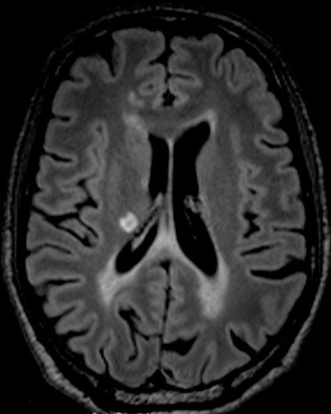
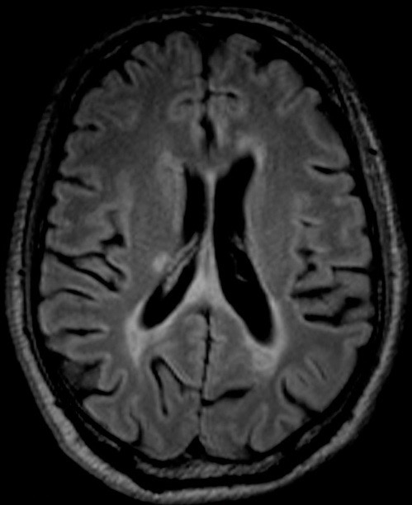
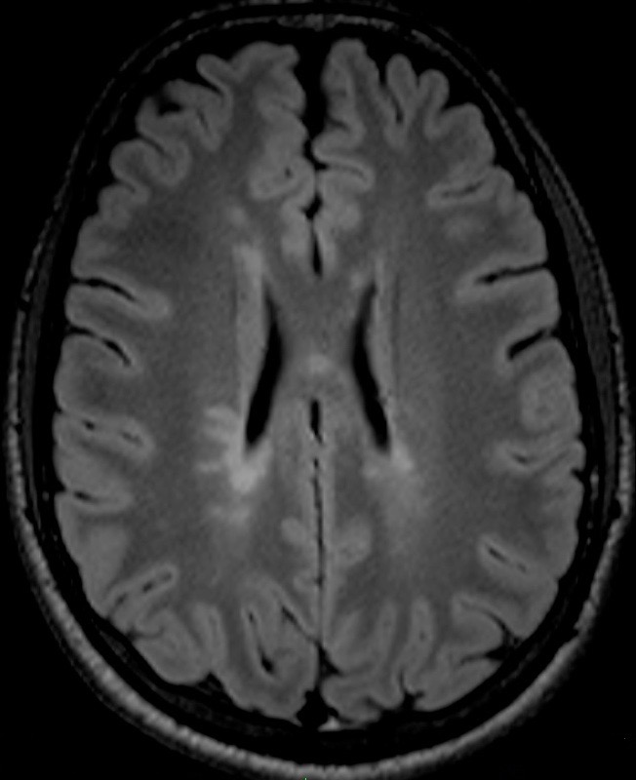
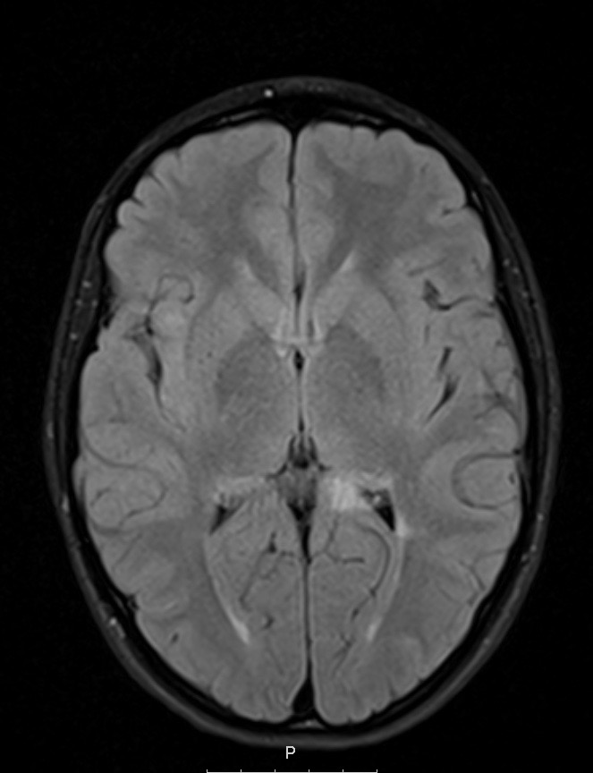
Figure 2 – T2 WI FLAIR axial images of diffuse lesions with poorly defined borders. MRI scan of a 16-year-old girl (A) and from a 14-year-old boy (B) at diagnosis. MRI scan from 51-year-old man at diagnosis (C) and 1 year after DMT (D).

C)
D)
B)
A)
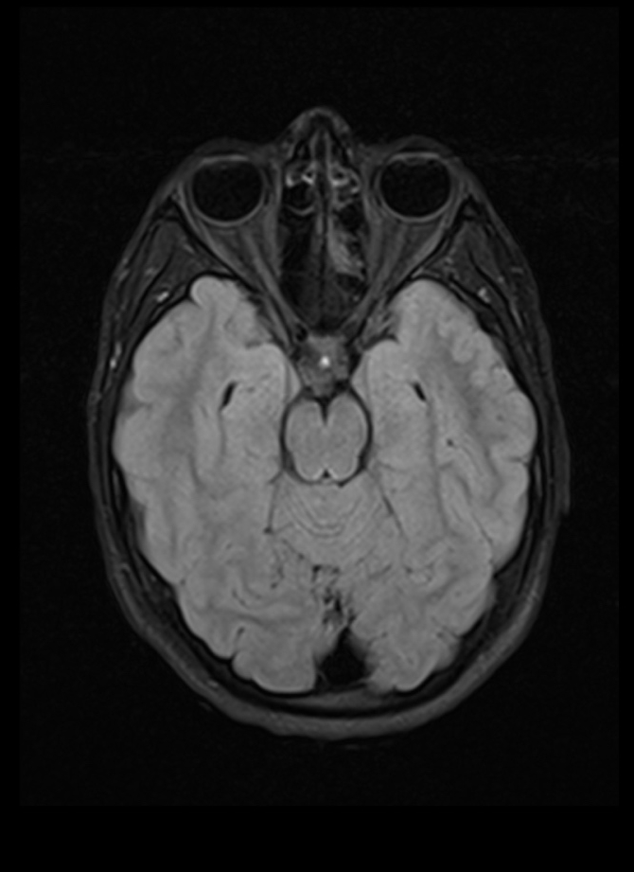
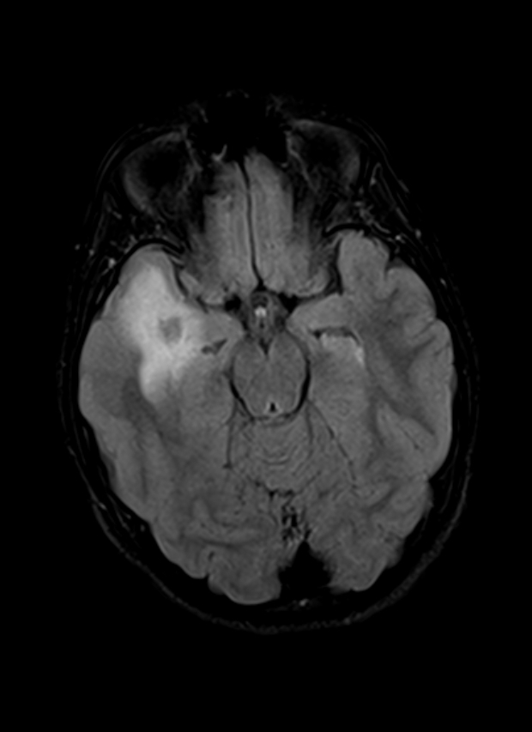
C)
A)

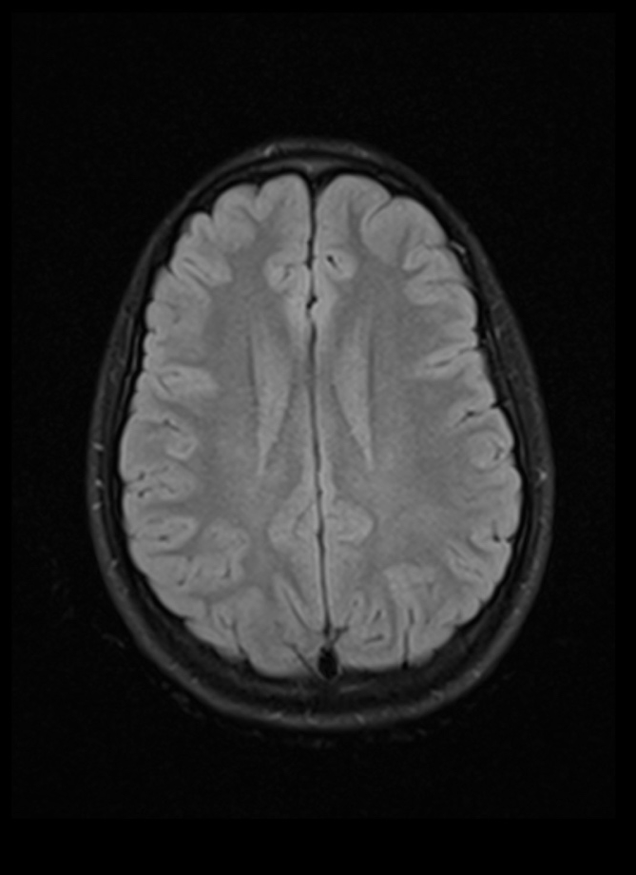
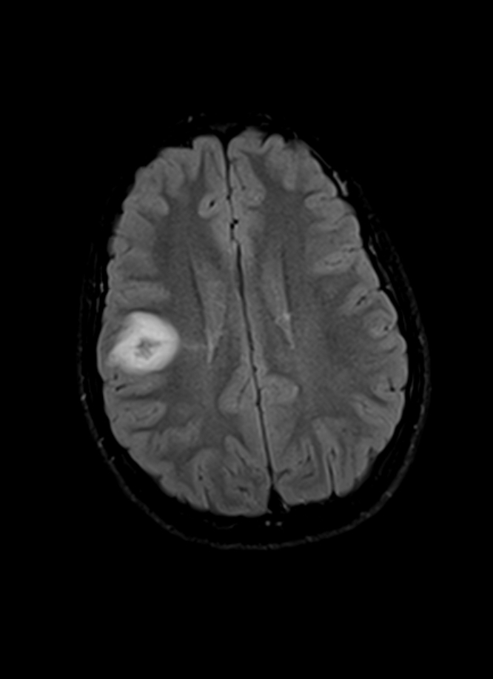
D)
B)

Figure 3 – Images from a 13-year-old girl with MS. T2 WI FLAIR axial images at diagnosis showing 2 diffuse lesions with poorly defined borders each with ≥1 cm of diameter (A, B). T2 WI FLAIR axial images 1 year after DMT (natalizumab) showing complete resolution of the lesions identified at diagnosis (C, D).

Regarding the NEDA-3 status, the percentage of patients who achieved this milestone and the individual analyses of its three composite parameters are shown in Figure 4. We found no statistically significant differences between groups, either in the NEDA-3 status achievement, nor on its 3 individual components. The NEDA-3 status was achieved by around a third of both POMS and AOMS patients. On the POMS group, there was no disability progression in any case, while the AOMS group had slightly better results in both the number of relapses and lack of imaging evidence of disease activity. Furthermore, we found that, compared to patients under natalizumab, patients who were under interferon beta as DMT of choice presented a 12 time-fold higher probability of not achieving the NEDA-3 status (p=0.029). The model was statistically significant (p=0.002) and explained 68% of the variability in whether one would not achieve the NEDA-3 status. We did not find any other statistically significant correlation between the NEDA-3 status achievement and demographic, clinical, laboratory or MRI features present at diagnosis.

POMS
28.6%

NEDA
No relapses
No progression
No evidence of MRI disease activity
AOMS
36.4%

Figure 4 – NEDA-3 status and its 3 components.

DISCUSSION

The gender distribution of POMS patients showed a greater number of female patients affected. Since the mean age at diagnosis was 14.9 (± 2.1) years, the female preponderance is consistent with a prior Portuguese study. Also, the international literature states that the increased female preponderance in RRMS starts after puberty.^{10,11}
Studies have shown that 40-50% of POMS patients present CSF oligoclonal bands, which is less than in AOMS patients.³ Our findings are consistent with these results. The mean EDSS score was higher in AOMS patients compared to POMS patients, both at diagnosis (not statistically significant) and after 1 year under DMT (p=0.032), which is due to a slower disease progression in POMS compared to AOMS.³
We found no statistically significant difference between POMS and AOMS related to the number of relapses prior to diagnosis, which can be due to a correct application of MS diagnostic criteria and a decrease in the time between first symptom onset and diagnosis. In our study, we did not find a statistically significant difference between groups in relapse topography, since late-onset POMS tends to resemble the typical neurologic syndromes of AOMS.²
Literature indicates that, at diagnosis, POMS patients present a greater total number of T2 WI lesions, with preference for infratentorial (brainstem and cerebellar) involvement and higher number of T1 WI and Gd+ lesions, compared to AOMS patients. Also, studies show that on follow-up MRI scans, POMS patients tend to have more new T2 WI and Gd+ lesions.^{10,12} In our study, we did not find a tendency or a statistically significant difference between groups in these variables, which can be due to the fact that late-onset POMS tends to have a more similar to AOMS’ MRI phenotype, than early-onset POMS (age <11 years old). Still, regarding MRI features, we found a statistically significant difference between groups in the number of T2 WI diffuse lesions with poorly defined borders, both at diagnosis and 1 year after DMT, with POMS patients evidencing fewer of these lesions than AOMS patients. This is a surprising finding, since POMS patients tend to present larger (more inflammatory) lesions with poorly defined borders. This might be partly explained by the fact that these lesions are more frequent in patients <11 years old and may vanish during disease course.
Studies on the natural history of MS suggest that in the early years of the disease, MS is rather inflammation-driven with a variable amount of time until an EDSS score of 3 is reached¹³. Although we were expecting a greater percentage of POMS patients reaching the NEDA-3 status, taking into account that DMT target the peripheral immune system and that POMS presents a greater underlying inflammatory burden than AOMS¹⁴, we did not find a statistically significant difference in the NEDA-3 status achievement between groups, which can be due to our small patient sample and partly to mean EDSS scores <3, found in both groups. Also, studies indicate that approximately 50% of AOMS achieve the NEDA-3 status after 2 years of follow-up¹⁵. Our short follow-up duration (12 months) can explain the lower percentage of AOMS patients reaching the NEDA-3 status compared with these studies. Nevertheless, it is important to note that POMS patients did not show any progression of disability (as measured by the EDSS score) throughout the study, although there were fewer children without relapses or MRI activity, when compared with the adult population. This only corroborates the inflammatory nature of the paediatric disease, although the repair capacity in the CNS (remyelination mechanisms, as an example) seems likely to be higher in children, to the point that there is no effective disability progression. Thus, NEDA-3 may not be sensitive enough to reflect this difference, which is very relevant in clinical practice. We might speculate on the possible benefit of NEDA-4 (in which data on brain atrophy would be added) in children and adolescents, but this will have to be objectively assessed and measured in future studies.
Even so, though relapses are more frequent in POMS than AOMS, our groups presented no statistically significant difference in the number of relapses during 1 year under DMT, including the NEDA-3 parameter “no relapses”, which can be explained by DMT efficacy. On the other hand, this can also be due to our short follow-up time, since it is reported that the median time between the first 2 neurologic episodes in these patients was estimated in 2.0 years.³
Regarding the “no evidence of MRI disease activity”, there were no statistically significant differences found between our two groups. This can be partly due both to the fact that there were also no differences in the number of relapses during 1 year under DMT¹⁵ and by the short follow-up time.
In our study, we found that, compared to patients under natalizumab as DMT, patients who were under interferon beta presented a 12 time-fold higher probability of not achieving the NEDA-3 status. This finding might be due to an increased efficacy of second line DMT compared to first line DMT, being that for this finding also contributes an important selection bias.
Our study encountered some limitations mainly due to its retrospective design. Since many needed data were inaccessible, allied to the small number of paediatric MS patients and to some obstacles related to MRI reading, the statistical power of our analyses was restricted. Additionally, we considered the first MRI available closest to the date of diagnosis as the baseline MRI and, since different DMT take distinct times to achieve an appreciable effect, patients were under effective therapy for diverse amounts of time, which may influence our study’s results. Another drawback that should be addressed is the short follow-up period (12 months) after DMT initiation, which in turn requires further effort to determine if the NEDA-3 status is sustained in a longer-term follow-up.

CONCLUSION

Our pilot study did not demonstrate a clear difference between POMS and AOMS among the various clinical and radiological variables that were considered, particularly regarding the use of NEDA-3 as a target. Nevertheless, despite the small magnitude of the differences found, the notion that the pediatric disease has a more marked inflammatory character is not excluded. It is from this perspective that one can also read the evident impact that drugs such as natalizumab have had on our paediatric population. This information suggests that treatment with more effective drugs may lead to a better control in the early onset of the disease, precisely at the stage where it is assumed to be more inflammatory. This is a relevant clinical milestone, allowing us to define the basis of future studies, where we aim to search for evolution markers and response to drugs in paediatric ages.

ACKNOWLEGDEMENTS

The authors acknowledge Doctor Carolina Maia for contributing to the analyses and interpretation of the MRI features and Professor Francisco Caramelo for the help and advice in the statistical analysis.

REFERENCES

1. Vollmer T, Huynh L, Kelley C, et al. Relationship between brain volume loss and cognitive outcomes among patients with multiple sclerosis: a systematic literature review. Neurol Sci. 2016;37(2):165-179. doi:10.1007/s10072-015-2400-1
2. Tenembaum SN. Pediatric Multiple Sclerosis: Distinguishing Clinical and MR Imaging Features. Neuroimaging Clin N Am. 2017;27(2):229-250. doi:10.1016/j.nic.2016.12.007
3. Alroughani R, Boyko A. Pediatric multiple sclerosis : a review. 2018:4-11.
4. Chitnis T. Disease-Modifying Therapy of Pediatric Multiple Sclerosis. Neurotherapeutics. 2013;10(1):89-96. doi:10.1007/s13311-012-0158-1
5. Kaunzner UW, Al-Kawaz M, Gauthier SA. Defining Disease Activity and Response to Therapy in MS. Curr Treat Options Neurol. 2017;19(5). doi:10.1007/s11940-017-0454-5
6. Giovannoni G, Turner B, Gnanapavan S, Offiah C, Schmierer K, Marta M. Is it time to target no evident disease activity (NEDA) in multiple sclerosis? Mult Scler Relat Disord. 2015;4(4):329-333. doi:10.1016/j.msard.2015.04.006
7. Giuliani M, Logoteta A, Prosperini L, Hirsch MN, Pozzilli C. Baseline characteristics associated with NEDA-3 status in fingolimod-treated patients with relapsing-remitting multiple sclerosis. Mult Scler Demyelinating Disord. 2017;2(1):10. doi:10.1186/s40893-017-0026-2
8. Calabresi PA, Kieseier BC, Arnold DL, et al. Pegylated interferon beta-1a for relapsing-remitting multiple sclerosis (ADVANCE): A randomised, phase 3, double-blind study. Lancet Neurol. 2014;13(7):657-665. doi:10.1016/S1474-4422(14)70068-7
9. Havrdova E, Galetta S, Hutchinson M, et al. Effect of natalizumab on clinical and radiological disease activity in multiple sclerosis: a retrospective analysis of the Natalizumab Safety and Efficacy in Relapsing-Remitting Multiple Sclerosis (AFFIRM) study. Lancet Neurol. 2009;8(3):254-260. doi:10.1016/S1474-4422(09)70021-3
10. Ruet A. Multiple Sclerosis on behalf SFSEP Update on pediatric-onset multiple sclerosis. Rev Neurol (Paris). 2018:1-10. doi:10.1016/j.neurol.2018.04.003
11. Correia AS, Augusto L, Meireles J, Pinto J, Sousa AP. Pediatric Multiple Sclerosis in Portugal: A Multicentre Study. Acta Med Port. 2016;29(7-8):425. doi:10.20344/amp.6346
12. Chabas D, Okuda DT, Glenn O, et al. Difference in disease burden and activity in pediatric patients on brain magnetic resonance imaging at time of multiple sclerosis onset vs adults. Arch Neurol. 2009;66(8):967-971. http://ovidsp.ovid.com/ovidweb.cgi?T=JS&PAGE=reference&D=med5&NEWS=N&AN=19667217.
13. Stangel M, Penner IK, Kallmann BA, Lukas C, Kieseier BC. Towards the implementation of ‘no evidence of disease activity’’ in multiple sclerosis treatment: The multiple sclerosis decision model.’ Ther Adv Neurol Disord. 2015;8(1):3-13. doi:10.1177/1756285614560733
14. General M. Increased Relapse Rate in Pediatric-Onset Compared With Adult-Onset Multiple Sclerosis. 2015;66(1):54-59.
15. Bigi S, Banwell B. Pediatric Multiple Sclerosis. J Child Neurol. 2012;27(11):1378-1383. doi:10.1177/0883073812452784

