Authoral Responsibility Statement

Please fill in the free fields with the relevant text. A full form must be signed by hand by all authors. Scan and submit the e-mail completed form (for depeditorial@actamedicaportuguesa.com)

manuscript #ID 13162

Title of the manuscript
The new General Data Protection Regulation and its implications on clinical information requests to health professionals

List of authors (in order of presentation in the manuscript)
Henrique Prata Ribeiro
André Ponte
Francisca Robalo Cordeiro
Fernando Vieira

Corresponding author
Henrique Prata Ribeiro

Correio Electrónico
henriqueprata@gmail.com

Morada
Rua Infanta D. Maria 68-B, 3º drto, 3030-330 Coimbra

I. Authorial contribution
The authors declare:
- Agree with the author proposed for corresponding author;
- Agree with the number of authors proposed for the manuscript and the respective submission order;
- Have contributed significantly to the preparation of the article identified above, according to recommendations for the Conduct, Reporting, Editing, and Publication of Scholarly work in Medical Journals prepared by the International Committee of Medical Journal Editors - ICMJE, namely (specify the individual contribution of each to the manuscript):
Data: 28/11/2019

Authorial Contribution
Henrique Prata Ribeiro
Name:
Contribuição:
Idea; Interpretation; Manuscript;
André Ponte
Name:
Contribuição:
Review; References
Francisca Robalo Cordeiro
Name:
Contribuição:
Legal manuscript; General Assessment
Fernando Vieira
Name:
Contribuição:
Manuscript; Interpretation; Review;

Name:
Contribuição:

Name:
Contribuição:

Name:
Contribuição:

Name:
Contribuição:

Name:
Contribuição:

II. Publication authorisation
The authors declare:
- Authorize that if this article is published in the Portuguese Medical Act, it will become joint property of the Portuguese Medical Acta and the authors,and cannot be reproduced, in whole or in part, without prior authorization from the editors. These restrictions do not apply to brief abstract summariespresented, or not, in scientific meetings.
- Agree to the provision of the article identified above, on paper and electronic support, by the Portuguese Medical Acta,in accordance with the Creative Commons Attribution License - Non-Commercial Use - Prohibition of The Realization of Derivative Works (Note: this means that the authors retain the copyright, but allow electronic copying, distribution and printing of articles published for non-commercial, academic purposes or individual, by any user, without permission or payment, provided that the authorship and the source are referred to, and the licensing of derivative works under the same terms is also imposed).

Data: 28/11/2019

Authors' signatures:
Henrique Prata Ribeiro
Nome:
Resident in Psychiatry
Título profissional:
Signature: 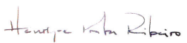

André Ponte
Nome:
Título profissional:
Resident in Psychiatry
Signature: 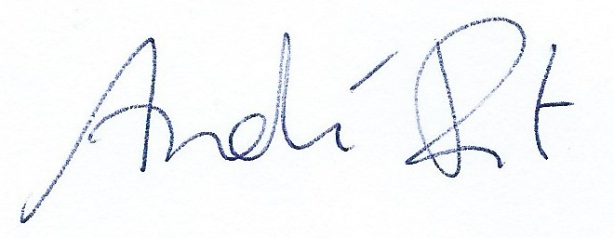

Francisca Robalo Cordeiro
Nome:
Título profissional:
Lawyer
Signature: 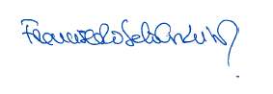

Fernando Vieira
Nome:
Título profissional:
Specialist in Psychiatry
Signature: 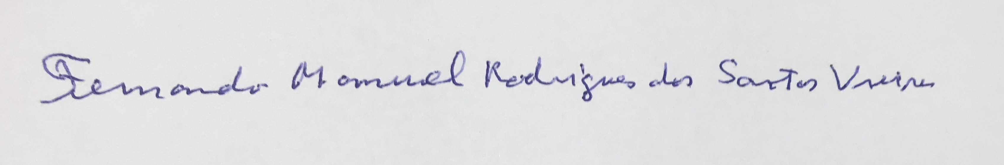

Name:
Título profissional:
Signature:

Name:
Título profissional:
Signature:

Nome:
Título profissional:
Signature:

Nome:
Título profissional:
Signature:

Nome:
Título profissional:
Signature:

Name:
Título profissional:
Signature:

