Rapid estimation of Impact of “lockdown” on COVID-19 epidemic in Portugal
Vasco Ricoca Peixoto^{a,b,c *}, André Vieira ^{a,} Pedro Aguiarª, Carlos Carvalho^{d}, Alexandre Abrantesª
Public Health Research Centre, National School of Public Health, Portugal
Affiliation of Authors
ª NOVA National School of Public Health, Public Health Research Centre, Universidade NOVA de Lisboa, Portugal
^{b} Public Health Unit, North Lisbon Health Centre, Lisbon, Portugal
^{c} European Programme for Intervention Epidemiology Training (EPIET), European Centre for Disease Prevention and Control (ECDC), Stockholm, Sweden
^{d} Unit for Multidisciplinary Research in Biomedicine, Abel Salazar Institute of Biomedical Sciences, Universidade do Porto, Portugal
* Corresponding E-mail: vrf.peixoto@ensp.unl.pt
Abstract
Background: Portugal took early action to control the COVID19 epidemic, imposing a lockdown when it recorded only 62.4 cases of COVID-19 per million inhabitants and no deaths. The Portuguese complied massively and quickly, reducing their overall mobility by 80%. This paper estimates the early impact of the “lockdown” in Portugal in terms of number of cases, deaths by COVID-19, and hospital and intensive care unit (ICU) occupied beds.
Methods: We forecasted the evolution of the epidemic curves after March 31 for cases and deaths and the evolution of the number of daily hospital inpatients (overall and in ICU), assuming that the impact of containment measures would start 14 days after lockdown implementation. We used exponential smoothing models for deaths, ICU and hospitalizations and an ARIMA model for number of cases. Models were selected considering fitness to the observed data until the 31st of march.
Results: Between April 1 and April 15, there were 146 (-25%) fewer deaths, 5568 (-23%) fewer cases and, as of April 15, there were 519 (-69%) fewer ICU inpatients and 508 (-28%) fewer overall hospital inpatients than forecasted with containment measures. On April 15 the number of ICU inpatients could have been three times higher than the observed value (229) if the intervention had been delayed beyond the end of March.
Conclusion: If the lockdown had not been implemented by mid-March, Portugal ICU capacity (528 ICU beds) would likely have been breached in the first half of april). The lockdown seems to have been effective in containing the rising number of cases, seriously ill COVID-19 patients and deaths. Early action allowed time for the National Health Service (NHS) to acquire protective equipment, to increase capacity to test and cope with the surge in hospital and ICU demand caused by the pandemic.

Introduction
Since there is no vaccine or treatment that prevents or cures COVID-19, governments have resorted to measures to contain and mitigate the spread of the virus in the community. Some of the most recent studies suggest that, in general, these public health measures have an impact on pandemic control. It is even suggested that each measure alone has advantages over non-intervention scenarios¹, but that only through a combined set of measures can the spread of the virus be contained ² ³ ⁴ ⁵
Portugal took early action to control the COVID19 epidemic, imposing restrictions on economic activity and social life when there were only 62.4 cases of COVID-19 per million inhabitants and virtually no deaths, a different epidemiological situation than that of Spain, Italy and the United Kingdom, when they took equivalent measures⁴. According to data compiled by the Oxford COVID-19 Government Response Tracker⁵, Portugal implemented in mid-March a relevant part of the containment and mitigation measures , including the cancellation of public events, school closures, workplaces and restriction of the national and international movement.
The Portuguese complied with the confinement measures and quickly reduced their overall mobility when Stringency Index increased and lockdown was imposed (Figure 1.) According to data published by Google⁶ ⁷ and Apple⁸ ⁴ the Portuguese reduced significantly their daily living mobility, including retail and leisure (-83%), parks and alike (-80%) and transport (-79%)⁷. The population in Spain also adhered effectively to government containment and mitigation measures. In Italy and UK, on the other hand, the population seems to have been slower and less effective in complying with the enacted measures.⁴

Figure 1. Evolution of the Oxford Contingency Index (green) and percentual variation of car mobility (blue) and walking (red) relative to January 13, according to Apple Mobility Data
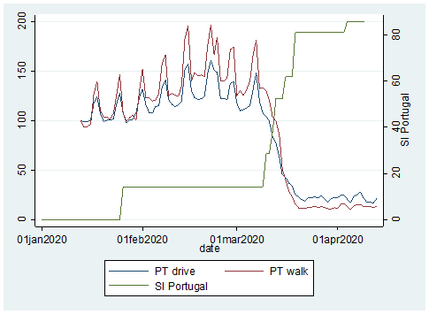
On March 16, 2020, the first death due to COVID-19 was registered in Portugal, 14 days after the first confirmed case of infection. In March 2020, 187 people died of COVID-19, or 2.3% of the 8 521 confirmed patient cases, a cumulative incidence of around 80 cases per 100 000 inhabitants and a lethality rate of 2.3%. In Portugal, most deaths by COVID-19 reported so far have occurred in individuals with underlying health conditions or at older ages.
This paper estimates the early health impact of the lockdown in Portugal, namely on the number of COVID-19 deaths and clinically serious cases (using number of hospital or intensive care unit beds occupied as proxy indicator of serious illness), and number of cases.

Methods
Data on the number of cases, deaths, and number of patients in hospital and ICU were collected from publicly available COVID-19 Situation Reports of the Directorate-General of Health of Portugal until April 15, 2020.
We estimated how the number of COVID-19 cases and associated deaths, hospital and ICU, would evolve in April 2020, without containment measures, by modeling a forecast for April based on the values recorded between March 1 and 31, in the absence of contingency measures. Then, we compared the predicted values with the observed values in April 2020. The available ICU and hospital inpatient data refer to the number of COVID-19 patients present in ICU and hospital each day implying a different analysis. For these outcomes we compare the values observed and expected on April 15 as a cumulative measure. We used SPSS expert modeler to find best fitting models for the time series until march 31, the tool fits the best model considering different types of exponential smoothing and ARIMA models for specific time-series⁹. Forecasts were obtained with exponential smoothing models applied to the time series of daily deaths, hospitalized in ICU, and total hospitalized patients until March 31. An ARIMA model was applied to the time-series of new cases, due to a better adjustment of the model. All models had good adjustments to the time-series until March 31, as demonstrated by the parameters meters presented in results. The analysis was performed in SPSS 26 considering the approach described by B. Tabachnich for traditional models forecast¹⁰.
We modelled observed data until March 31 because reduction in mobility and contacts between citizens was effective in mid-March 2020 (Figure 1). We considered a delayed effect of measures starting 14 days after the lockdown considering different pieces of evidence on the period from infection to onset of symptoms to the detection of cases, hospitalization (general ward or intensive care unit), and death, despite heterogeneous results in different publications¹¹ ¹² ¹³. One study found the median incubation period of COVID-19 is 7 days (IQR:4-11)¹¹ , another that the median time from first symptom to dyspnoea being 5 days, to hospital admission was 7 days, and to ARDS was 8 days ¹²; an interrupted time series study suggest that the onset of reduction effects after COVID-19 lockdown in Hubei and Guangdong on incidence and mortality were observed after a period ranging from 7 to 17 days and 10 days, respectively¹⁴. Considering this and for and easier reading and interpretation we assumed in the analysis that the impact would begin to be observed for all the outcomes from April 1, 14 days after the lockdown.

Results
Between April 1 and April 15, there were 146 fewer deaths (-25%) and 5.568 fewer cases (-23%) than what was estimated by the model. On April 15, there were 519 fewer patients in ICU (-69%) and 508 fewer hospital inpatients (-28%). These results suggest that the containment measures may have contributed to the reduction of mortality and serious morbidity due to COVID-19 (patients that require hospital or ICU admission).
Impact in daily deaths
Between 1 and 15 April, there were 442 deaths from COVID-19, 146 (-25%) fewer than the 588 that would be expected for that period if no containment and mitigation measures had been implemented. The exponential smoothing model for deaths (until March 31) had good fitting to observed data R2=0.91, smoothing parameter test p<0.001, quality adjustment Ljung Box P=0.75, FAC and FACP not significant (Figure 2.).

Figure 2. Observed and predicted nº of daily deaths by COVID-19, with 95% confidence levels (orange dashed line- date of lockdown; dashed grey line- beginning of forecast)
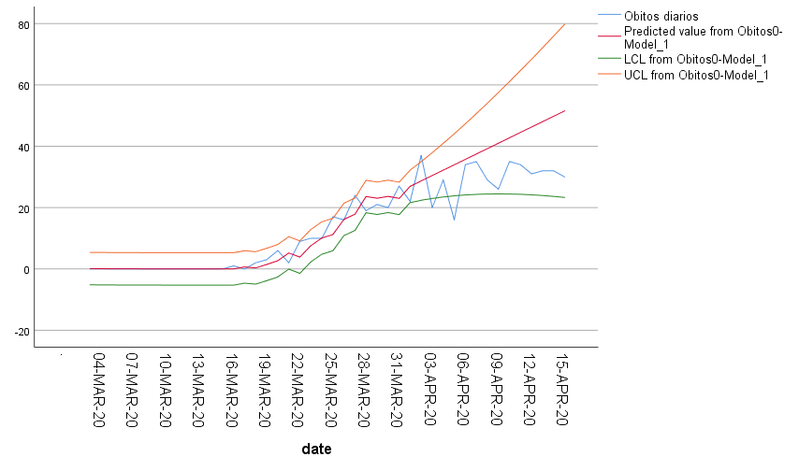
Daily Deaths Obs.
Predicted Deaths
CI95% lower
CI95% higher

Impact in ICU inpatients
As of April 15, we forecasted that 748 patients would be occupying ICU beds. We observed 519 fewer patients in ICU than the predicted value by that date (-69%). ICU bed occupation fell short of the lower bound of the 95% confidence interval generated by the model throughout the period.
Between 1 and 15 April, there were on average 237 COVID-19 occupied ICU beds, 269 fewer than the average 506 expected in the same period (-53%), without containment and mitigation measures. For this analysis, we used an exponential smoothing model of number of patients in ICU (March 31), R2=0.98, p<0.001 smoothing parameter test, Ljung Box adjustment quality P=0.96, FAC and FACP not significant (Figure 3.).

Figure 3. Observed and predicted nº of daily ICU inpatients with COVID-19, with 95% confidence levels (orange dashed line- date of lockdown; dashed grey line- beginning of forecast; Red dashed line -ICU beds capacity: 528)
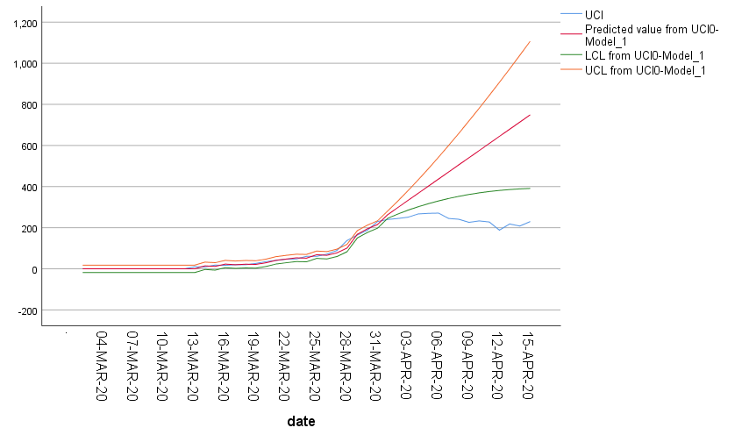
ICU capacity
Patients in ICU
Predicted ICU
CI95% lower
CI95% higher

Impact in overall hospital beds occupation
As of April 15, we predicted 1810 overall hospital beds occupied. We observed 508 fewer than the predicted value for that date (-28%).
Between 1 and 15 April, there was a daily average of 1.158 hospital beds occupied by COVID-19 patients, 142 fewer than the 1.300 occupied beds expected (-11%) if no containment and mitigation measures had been put in place. For this analysis we used the exponential smoothing model of hospitalized patient numbers (until March 31), R2=0.94, smoothing parameter test p<0.001, Ljung Box P=0.84 adjustment quality, FAC and FACP not significant (Figure 4.).

Figure 4. Observed and predicted nº of daily hospital inpatients (All) with COVID-19, with 95% confidence levels (orange dashed line- date of lockdown; dashed grey line- beginning of forecast)

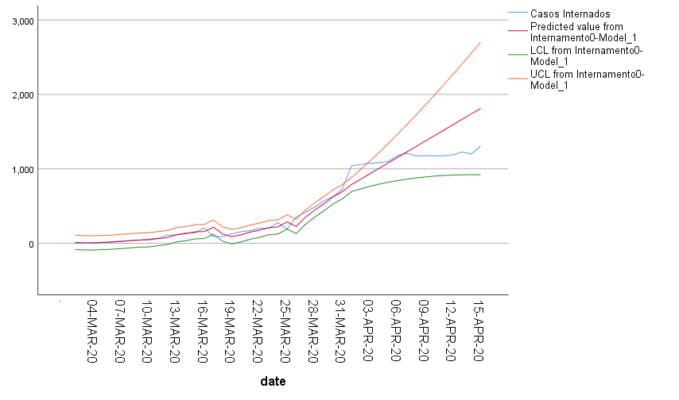
Hospitalized Patients
Predicted Hospitalized Patients
CI95% lower
CI95% higher

Impact in daily new cases
Between 1 and 15 April, there were 5.568 fewer cases than the 24.405 cases forecasted (-23%). This indicator remained under the lower bound of the 95% confidence interval generated by the model after April 9. The forecast used an ARIMA model (2,1,0) adjusted until March 31 for the number of new daily cases 1, R2=0.86, test parameters of the model p<0.05, adjustment quality Ljung Box P=0.95, FAC and FACP not significant (Figure 5.)

Figure 5. ARIMA model. Daily nº of observed and predicted nº of cases of COVID-19 and 95% confidence intervals. Orange dashed line - date of lockdown; dashed grey line- beginning of forecast
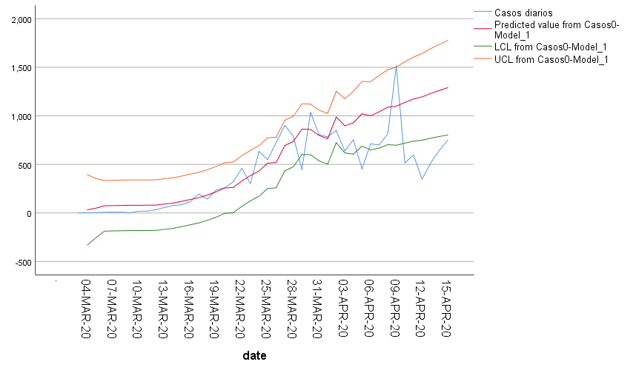
Daily Cases Obs.
Predicted Case
CI95% lower
CI95% higher

Summary of Results
Between April 1 and April 15, there were 146 (-25%) fewer deaths, 5.568 (-23%) fewer cases and, as of April 15, there were 519 (-69%) fewer ICU inpatients and 508 (-28%) fewer overall hospital inpatients than expected with containment measures (Table 1.) On April 15 the number of ICU inpatients could have been greater than 740, more than 3 times higher than the observed value if the intervention was delayed beyond the end of March.

Table 1. Predicted and Observed values and absolute and relative differences for different COVID-19 indicators from April 1st to 15th
 |  | Predicted | Observed | Dif | Dif%
Deaths | Average number of daily Deaths | 39.23 | 29.47 | -9,76 | -0.25
 | Total Deaths | 588 | 442 | -146 | -0.24
Patients in ICU | Average number of occupied beds | 237.33 | 505.7517 | -268 | -53%
 | Total ICU inpatients on April 15 | 229 | 748 | -519 | -69%
All Hospitalized Patients | Average number of inpatients | 1157.93 | 1299.689 | -142 | -11%
 | Total inpatients on April 15 | 1302 | 1810 | -508 | -28%
Cases | Average number of daily new cases | 567 | 428 | -139 | -25%
 | Total cases on April 15 | 24.405 | 18.837 | -5.568 | -23%

Discussion
The findings of this study suggest that an early Government action, implementing a strict containment and mitigation policy and a high level of compliance of the Portuguese population were effective in reducing mortality and severe morbidity of COVID-19 (those requiring hospitalization or ICU), in line with one of the main public health objectives communicated by the ECDC on April 23.¹⁵
Results are consistent across different outcomes: number of daily cases, number of deaths, number of severe cases, as measured by two proxies: daily number of overall hospital and ICU inpatients.
This simple interrupted time series method allows for an early retrospective estimate of the impact of measures that may be repeated whenever containment measures are changed and gives an intuitive way to visualize the impact the short term.
Our estimates are conservative. The interrupted time-series method assumed a fixed cut-off date on March 31, 14 days after lockdown, to start forecasting the possible impact on the number of deaths, hospital and ICU inpatients and cases. The impact of the lockdown measures is likely to have started earlier and gradually, rather than on specific moment in time.¹⁴ ¹⁶ However, since mobility reduction happened quickly in Portugal, by the middle of March, the effect would not be as gradual as if there had been a slower reduction in mobility and social contacts. Our time series models incorporate a flattening of the new cases and death curves which was already happening in the last days of March 2020. This influences the forecast making it more conservative.
We cannot isolate the effect of specific measures on different outcomes. ICU cases and deaths are more strongly influenced by the number of cases in elderly population, since they have a higher risk ¹⁷ and may have a larger impact if more cases are prevented in this population.
Different methods have been used internationally for estimating impact of COVID-19 containment measures through Susceptible Infected and Recovered models and others ¹⁸ ¹⁹ ²⁰ ²¹ ²² including retrospectively through interrupted time-series ¹⁴ ¹⁶. The latter consistently found a relevant impact of lockdown policies, with variable lags from lockdown to maximal impact. We believe this conservative forecast to be adequate, considering the short forecasting period and that some behavioral change would occur even without severe lockdown measures.

Conclusions

In Portugal, early and quick containment measures and a reported high level of compliance of the population were associated with a relevant reduction in the number of serious cases and deaths by COVID-19. Results were apparent less than two weeks after most lockdown measures.
Between April 1 and April 15, there were 146 fewer deaths (-25%), 5.568 fewer cases (-23%) and, as of April 15, there were 519 fewer ICU inpatients (-69%) and 508 fewer overall hospital inpatients (-28%) than what would have been expected if no containment measures had been put in place. On April 15 the number of ICU inpatients could have been greater than 700, a number three times higher than the observed value if the intervention was delayed beyond the end of March. These results suggest that the containment measures may have contributed to the reduction of mortality and serious morbidity due to COVID-19.
The capacity of the National Health Service to care for serious COVID-19 cases, (528 intensive care unit beds at the start of the epidemic), would likely have been breached if containment measures had been delayed to the end of March. In May, ICU beds capacity had been increased to 713 according to the Health Ministry ²³.
Portugal is now in a good position to start easing social distancing, relaunching economic and social life. During this period, it has to a) maintain a high level of epidemiological surveillance, to detect early and precisely any new surge of the epidemic, b) focus on keeping the number of serious cases and deaths down, but focusing on the high risk population (people aged 70+, and those with debilitating illness, namely those in long-term care institutions), c) protect health care and other high risk professions, c) keep the transmission rate under control, as recommended in ECDC Risk Assessment of April 9¹⁵ and the European Comission²⁴.

Funding
Conflicts of interest: None declared.

Key points
- Early containment measures and lockdown in Portugal were effective in controlling the epidemic and may have allowed ICU capacity to cope with demand that could have been surpassed by April 15, if lockdown was delayed;

- This may have bought more time for preparedness and response to allow for the implementation of other measures, including acquisition of protective equipment and increasing health-care capacity.

References
1. Koo JR, Cook AR, Park M, et al. Interventions to mitigate early spread of SARS-CoV-2 in Singapore: a modelling study. Lancet Infect Dis. March 2020. doi:10.1016/s1473-3099(20)30162-6
2. The effect of non-pharmaceutical interventions on COVID-19 cases, deaths and demand for hospital services in the UK: a modelling study | CMMID Repository. https://cmmid.github.io/topics/covid19/control-measures/uk-scenario-modelling.html. Accessed April 6, 2020.
3. Kraemer MUG, Yang C-H, Gutierrez B, et al. The effect of human mobility and control measures on the COVID-19 epidemic in China. Science (80- ). 2020;4218(March):eabb4218. doi:10.1126/science.abb4218
4. Ricoca Peixoto V., Vieira A., Aguiar P., Sousa P., Abrantes A. “Timing”, Adesão e Impacto Das Medidas de Contenção Da COVID-19 Em Portugal | COVID-19. https://covid360.unl.pt/?p=1595. Accessed May 9, 2020.
5. Oxford COVID-19 Government Response Tracker | Blavatnik School of Government. https://www.bsg.ox.ac.uk/research/research-projects/oxford-covid-19-government-response-tracker. Accessed April 7, 2020.
6. Google. COVID-19 Community Mobility Reports. https://www.google.com/covid19/mobility/. Accessed April 4, 2020.
7. Barómetro Covid-19. Mobilidade dos Portugueses à lupa da Google e do Barómetro Covid-19. https://barometro-covid-19.ensp.unl.pt/mobilidade-dos-portugueses-a-lupa-da-google-e-do-barometro-covid-19/. Accessed April 24, 2020.
8. Apple. COVID‑19 - Mobility Trends Reports. https://www.apple.com/covid19/mobility. Accessed April 18, 2020.
9. IBM Knowledge Center. IBM SPSS Time Series Modeler. https://www.ibm.com/support/knowledgecenter/SSLVMB_24.0.0/spss/trends/idh_idd_tab_vars.html. Accessed May 12, 2020.
10. Tabachnick BG, Fidell LS. Using Multivariate Statistics (6th Ed.).; 2012. doi:10.1037/022267
11. Wang P, Lu J, Jin Y, Zhu M, Wang L, Chen S. Statistical and network analysis of 1212 COVID-19 patients in Henan, China. Int J Infect Dis. April 2020. doi:10.1016/j.ijid.2020.04.051
12. Wang D, Hu B, Hu C, et al. Clinical Characteristics of 138 Hospitalized Patients with 2019 Novel Coronavirus-Infected Pneumonia in Wuhan, China. JAMA - J Am Med Assoc. 2020. doi:10.1001/jama.2020.1585
13. Yang X, Yu Y, Xu J, et al. Clinical course and outcomes of critically ill patients with SARS-CoV-2 pneumonia in Wuhan, China: a single-centered, retrospective, observational study. Lancet Respir Med. 2020;8(5):475-481. doi:10.1016/S2213-2600(20)30079-5
14. Medeiros de Figueiredo A, Daponte Codina A, Moreira Marculino Figueiredo DC, Saez M & Cabrera León A. Impact of lockdown on COVID-19 incidence and mortality in China: an interrupted time series study. [Preprint]. Bull World Health Organ. E-pub: 6 April 2020. doi: http://dx.doi.org/10.2471/BLT.20.256701.
15. Coronavirus disease 2019 (COVID-19) in the EU/EEA and the UK – ninth update, 23 April 2020. Stockholm: ECDC; 2020. https://www.ecdc.europa.eu/en/publications-data/rapid-risk-assessment-coronavirus-disease-2019-covid-19-pandemic-ninth-update. Accessed April 30, 2020.
16. Siedner MJ, Harling G, Reynolds Z, Gilbert RF, Venkataramani A, Tsai AC. Social distancing to slow the U.S. COVID-19 epidemic: an interrupted time-series analysis. medRxiv. April 2020:2020.04.03.20052373. doi:10.1101/2020.04.03.20052373
17. Verity R, Okell LC, Dorigatti I, et al. Estimates of the severity of coronavirus disease 2019 : a model-based analysis. Lancet Infect Dis. 2020;3099(20):1-9. doi:10.1016/S1473-3099(20)30243-7
18. Leung K, Wu JT, Liu D, Leung GM. First-wave COVID-19 transmissibility and severity in China outside Hubei after control measures, and second-wave scenario planning: a modelling impact assessment. Lancet. 2020;395(10233):1382-1393. doi:10.1016/S0140-6736(20)30746-7
19. Lai S, Ruktanonchai NW, Zhou L, et al. Effect of non-pharmaceutical interventions for containing the COVID-19 outbreak: an observational and modelling study. medRxiv. March 2020:2020.03.03.20029843. doi:10.1101/2020.03.03.20029843
20. Kucharski AJ, Russell TW, Diamond C, et al. Early dynamics of transmission and control of COVID-19: a mathematical modelling study. Lancet Infect Dis. 2020;0(0). doi:10.1016/S1473-3099(20)30144-4
21. Hellewell J, Abbott S, Gimma A, et al. Feasibility of controlling COVID-19 outbreaks by isolation of cases and contacts. Lancet Glob Heal. 2020;0(0). doi:10.1016/S2214-109X(20)30074-7
22. WHO Collaborating Centre for Infectious Disease Modelling ; MRC Centre for Global Infectious Disease Analysis; Abdul Latif Jameel Institute for Disease and Emergency Analytics; Imperial College London. Impact of non-pharmaceutical interventions (NPIs) to reduce COVID-19 mortality and healthcare demand. 2020. https://www.imperial.ac.uk/mrc-global-infectious-disease-analysis/news--wuhan-coronavirus/. Accessed March 17, 2020.
23. Diário de Notícias. Portugal nunca utilizou a sua capacidade total em cuidados intensivos. https://www.dnoticias.pt/pais/portugal-nunca-utilizou-a-sua-capacidade-total-em-cuidados-intensivos-CF6241613. Accessed May 9, 2020.
24. European Commission. A European roadmap to lifting coronavirus containment measures . https://ec.europa.eu/info/live-work-travel-eu/health/coronavirus-response/european-roadmap-lifting-coronavirus-containment-measures_en. Accessed April 20, 2020.

