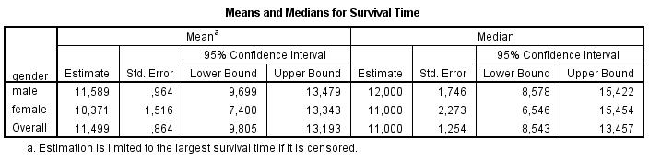

Overall Comparisons
 | Chi-Square | df | Sig.
Log Rank (Mantel-Cox) | ,032 | 1 | ,858
Breslow (Generalized Wilcoxon) | ,007 | 1 | ,933
Tarone-Ware | ,016 | 1 | ,900
Test of equality of survival distributions for the different levels of gender.
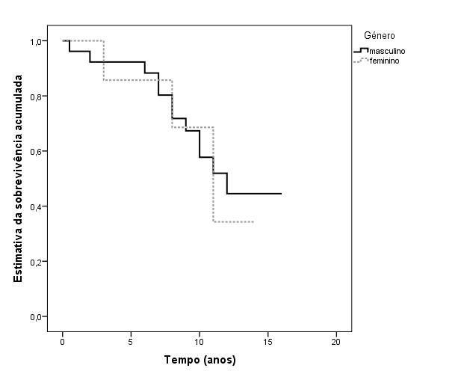

Estimativa de Kaplan-Meier da função de sobrevivência estratificada por género
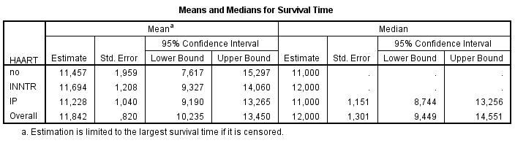

Overall Comparisons
 | Chi-Square | df | Sig.
Log Rank (Mantel-Cox) | ,297 | 2 | ,862
Breslow (Generalized Wilcoxon) | ,317 | 2 | ,854
Tarone-Ware | ,305 | 2 | ,859
Test of equality of survival distributions for the different levels of HAART.

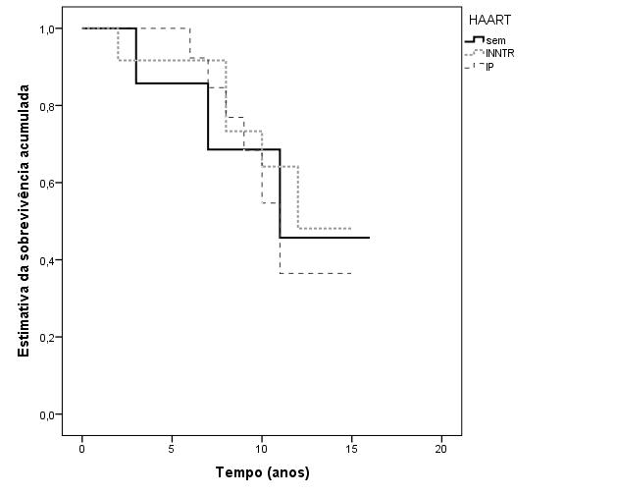
Estimativa de Kaplan-Meier da função de sobrevivência estratificada por terapêutica
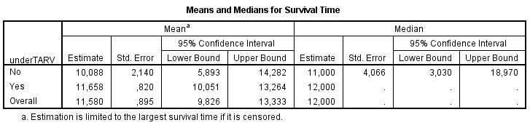

Overall Comparisons
 | Chi-Square | df | Sig.
Log Rank (Mantel-Cox) | ,738 | 1 | ,390
Breslow (Generalized Wilcoxon) | 1,326 | 1 | ,250
Tarone-Ware | 1,041 | 1 | ,307
Test of equality of survival distributions for the different levels of underTARV.
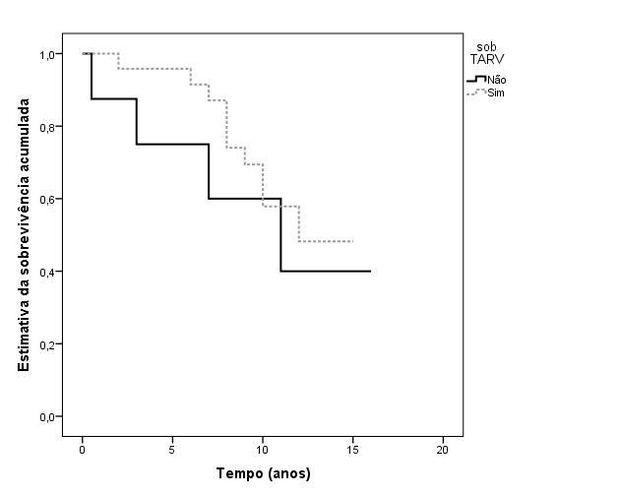
Estimativa de Kaplan-Meier da função de sobrevivência estratificada por TARV
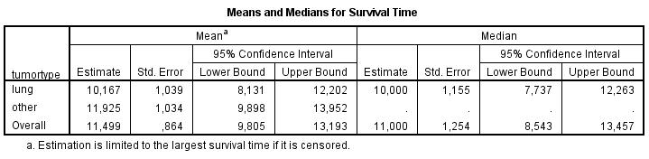

Overall Comparisons
 | Chi-Square | df | Sig.
Log Rank (Mantel-Cox) | 1,547 | 1 | ,214
Breslow (Generalized Wilcoxon) | ,425 | 1 | ,515
Tarone-Ware | ,897 | 1 | ,343
Test of equality of survival distributions for the different levels of tumortype.

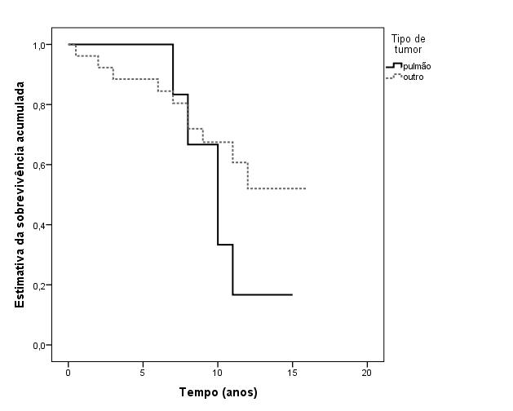
Estimativa de Kaplan-Meier da função de sobrevivência estratificada por tipo de tumor

